**ASSIGNMENT COVER SHEET**

|  |  |  |  |  |  |  |  |  |
| --- | --- | --- | --- | --- | --- | --- | --- | --- |
| **Course: BSc Computing** | | | | **Year: 3** | | **Software Engineering 3** | | |
| Assignment No: 1 | | **Title: The Design and Development of Client-Driven Software Solution Using a Rapid Application Development/Agile Hybrid Development Methodology** | | | | | | |
| Date due out: | Date due in: | | Extension date: | | | | | Extension agreed by: |
| **Student Name:** Roshan Giri  **Student ID:** 18406492 | | | | | | | **Tutor: Mark Johnson** | |
| Student comments, specific request for feedback etc. | | | | | Marker’s General View of the work | | | |

**ASSESSMENT FEEDBACK:**

|  |  |  |  |  |  |  |  |  |
| --- | --- | --- | --- | --- | --- | --- | --- | --- |
| **RATING SCALE** | **Excellent (A- - A+)** | | **Good**  **(B- - B+)** | | **Satisfactory**  **(C- - C+)** | **Needs some more work**  **(D- - D+)** | | **Needs much more work**  **(F+ - G)** |
| **Problem Domain Elicitation**  **(15%)**  (Including Problem Domain Workshop Plans, Findings and Facilitation) |  | |  | |  |  | |  |
| **Requirement Specification Formulation**  **(15%)**  (Including Requirements Elicitation Workshop Plans Findings, Facilitation and Final Specification Documentation) |  | |  | |  |  | |  |
| **Facilitation Observation and Critical Review**  **(10%)** |  | |  | |  |  | |  |
| **Prototype System Design (Including Design Documentation)**  **(10%)** |  | |  | |  |  | |  |
| **Prototype**  **(30%)**  (Including Prototype Functionality, Quality of Application Code and Implementation Development Plan) |  | |  | |  |  | |  |
| **Testing/Evaluation Strategy**  **(10%)** |  | |  | |  |  | |  |
| **Client Presentation (10%)** |  | |  | |  |  | |  |
| Specific aspects of your assignment that the marker likes: | | | | Specific aspects of your assignment that need more work: | | | | |
| Tutor’s Signature: | | Date: | | | | | Grade: | |

**Demo Video Link:** <https://northampton.mediaspace.kaltura.com/media/Claybrook+Demo/1_b4wimprv>

Table of Contents

1 Introduction 3

1.1 Project Background 3

1.2 Project Aims and Objectives 3

2 Requirement Engineering 4

2.1 Elicitation Activities 4

2.1.1 Individual Workshop 1 Plan (Problem Domain Understanding) 4

2.1.2 Group Workshop 1 Plan (Problem Domain Understanding) 8

2.1.3 Workshop 1 Findings (Problem Domain Understanding) 11

2.1.4 Individual Workshop 2 Plan (Problem Resolution and Specification Formulation) 13

2.1.5 Group Workshop 2 Plan (Problem Resolution and Specification Formulation) 15

2.1.6 Workshop 2 Findings (Problem Resolution and Specification Formulation) 17

2.1.7 Workshop Observation Critical Review 17

2.1.8 Other Problem Domain Research 18

2.2 Requirements Specification 27

2.2.1 Problem Domain Description 27

2.2.2 Functional Requirements 29

2.2.3 Proposed Prototype Development Blocks/Priority of Development 33

3 System Analysis & Design (Software Development Block 1) 34

3.1 Preliminary Design Stages 34

3.1.1 Textual Analysis 34

3.1.2 Significant Event Analysis 35

3.2 Activity UML Diagram 35

3.3 Use Case Diagram 37

3.4 Sequence Diagram 38

3.5 System Navigation Diagram 38

3.6 Database Design 39

4 System Build and Technical Notes (Software Development Block 1) 40

5 System Testing & Evaluation Strategy (Software Development Block 1) 49

6 Conclusion 51

7 References 52

8 Appendix 52

8.1 Wireframes 52

8.2 Mockups 58

# Introduction

This report details the design and development of software solution for Claybrook Zoo, which is a small family-oriented zoo located in the Northwest of England. We use the Rapid Application Development Method (RAD) for the development of the software system. Throughout the development of the software system solution, there is continuous interaction of our development team with clients by workshops.

## Project Background

Claybrook Zoo is a small family-oriented zoo in the Northwest of England. It was established in 1965. The zoo uses the clerical based system for the management of the animals. All the animal’s records are stored in a clerical based system. The storing of the animal record in a paper is a very slow process and very time-consuming. The tickets for visiting the zoo are also managed in a clerical way. Sponsors for animals are also managed by clerical methods. Matthew Jones, who is the manager of the zoo has requested us to computerize the clerical based management system by developing software for the zoo which would make the system faster and easier. The search for animal records would be effective and faster in the software system.

The zoo has provided us with sufficient information regarding the current clerical management system along with the system requirements. The information provided to us is inconclusive. Further information would be collected through workshops. The workshop would be conducted with four key stakeholders i.e. Mr. Mark Jones (Manager), Mr. John Smith (Visitor), Ms. Georgia Rodgers (Senior Administrator), and Ms. Laura Brown (Sponsor).

## Project Aims and Objectives

The main aim of this project is to design and develop a software system for Claybrook zoo and to establish the possibility of such a computerized system. The following objectives have to be completed in order to achieve this aim;

* Elicitation activities
* Compose individual and group workshop plan to elicit the problem domain of the proposed system.
* Record and analyze the findings of the workshop conducted with the key stakeholders.
* Compose individual and group workshop plans for the workshop regarding the problems and specification management.
* Record and analyze the finding conducted in the workshop regarding the problems and specification management.
* Critical review of the workshop findings of the problem domain understanding should be produced.
* Investigate other problem domain relevant areas such as comparable systems, legal requirements, and so on before coming to the workshops.
* Requirement Specification
* Problem domain description detail.
* Find out existing business operations and imitations.
* Functional requirements for the proposed software development.
* Draft the proposed prototype development blocks/ priority of development.
* System Analysis and Design of the prototype system
* Analyze the information collected in the requirement specification part.
* Create the static Unified Modeling Language (UML) class diagram for the Claybrook Zoo. UML class diagram should be designed to draw the system architecture for the zoo.
* Create an ERD for the Claybrook Zoo which describes the database structure of the system.
* System build and technical notes of the proposed software system.
* Testing and Evaluation of the software system.
* Conclusion of the overall software project development.

# Requirement Engineering

The elicitation activities and requirement specifications are outlined in this part of the report. All the information is collected and defined.

## Elicitation Activities

Elicitation activity is a technique of collecting useful data that can be used for the development of any project. Relevant information is collected using elicitation techniques. The elicitation techniques used in this phase are JAD (Joint Application Design), a comparable system, and development relevant legislation.

### Individual Workshop 1 Plan (Problem Domain Understanding)

We conducted the workshop using the JAD principles. The main aim was to complete an understanding of the problem domain.

Before coming to the workshop, the background information of the project, comparable systems, development relevant legislation, and the project brief have been examined. It is important to review the information to understand the problem domain.

To conduct the workshop, the four key stakeholders were made available;

* **Mark Jones:** The current zoo manager who is also an expert on existing organizational procedures and practice within the zoo.
* **John Smith:** An existing, regular visitor of the zoo. He has good insight into the current visiting experience.
* **Georgia Rodgers:** A senior Administrator of the zoo. She is also responsible for running the sponsorship scheme.
* **Laura Brown:** Owner of a local small business and existing sponsor of the animals in the zoo.

#### Rationale

The rationale for the workshop 1 is to develop a broad understanding of the problem domain. To complete the rationale the following objectives for the meeting with key stakeholders have been set;

* The stakeholders should be informed about the agenda, objectives, outcomes of the workshop. Also, they should be briefed about the engagement rules about the workshop.
* To clearly understand the reason for the development of the new prototype software system.
* To clearly understand the current clerical based system methods and the limitations of the system provided in the project brief and other documents.
* Review the system requirements of the zoo provided by the client in the project brief for understanding the information without any confusion.
* Create a document of top priority features and functionality for the development of the prototype software system. The document should be later signed off by the clients with the presence of proper authority.
* The collected information should be clearly understandable by both the client and developer team. The information should be collected and listed on the basis of importance.
* Sum up the workshop findings and set a new date for a future workshop with the stakeholders.

#### Agenda/ Tool Selection

The agenda and tool selection for the workshop determine the technique and timings. It is important to elicit the proper information so that we can meet the rationale of the workshop mentioned above. The individual agenda and tool selection for the workshop is shown in Table 1 Agenda/ Tool Selection (Individual)

|  |  |
| --- | --- |
| Workshop Meeting Topics | Time |
| Introduction   * Introduction of team members that are present in the workshop by conducting an attendance. * Brief team members and stakeholders of the workshop process including the objectives, agenda, and outcomes. * Provide necessary documents and other relevant materials for the team members and stake holders * Explanation of engagement rules and regulations during the workshop session. * Start the workshop session with each stakeholder by establishing a motive for the new prototype software system. | 07:00 |
| Current Business Model/Operation   * The complete review of the documents, work practices, models, limitations of the zoo should be gathered and discussed with stakeholders from their aspect. * Check whether the information provided through brief and other documents are correct. | 07:15 |
| System Requirements   * Check whether the system requirements provided in the documents are accurate. * Ask each stakeholder about what they want in the prototype software system. * Talk about other additional features and functionality that the stakeholder wants in their prototype solution software system. * Review the information provided by the client regarding the system requirements. | 07:45 |
| Features Prioritization   * Create a document prioritizing the main features and functionalities of the prototype system. * Make sure that the priority features and functionalities document is approved by each stakeholder. | 08:20 |
| Workshop Understanding   * Make sure that all the information collected during the workshop is understandable and is agreed upon by the stakeholders. | 08:40 |
| Closing   * Summarize the workshop findings and outcomes. * Fix a date for another workshop, explaining the aims and objectives of the next workshop to be conducted | 09:00 |

*Table 1: Agenda/ Tool Selection (Individual)*

#### Participant Engagement Commitment

The participant engagement commitment guidelines are created so that there is no difference between the stakeholders and the developer teams. The guidelines also help in providing a rich environment to talk about the software system with stakeholders. The guidelines for participant engagement commitment are shown below:

* Each and every participant are equal.
* All members of the group should be present during the entire session.
* No side conversation and noise.
* In the session, one group member should observe the other members on their session time and learn from them and vice versa.
* The recommended session agenda should be followed.

**Individual prepared Questions**

***Mark Jones (Zoo manager and expert)***

* Would it be possible to list out some of your roles and responsibility?
* What made you to change from your old framework to the enhanced one? What were the loop holes in your previous system so that we can improve it in the new system?
* What were the difficulties that you were facing in the clerical based system?
* How did you manage all the records of the zoo in the clerical system?
* What may be your expectation from us? Any extra feature you would like us to append?
* Are there things that you would never want us to include in this software?
* By what way will you measure accomplishment/success of the software?

***John Smith (Visitor)***

* What are the problems that you are facing in the current system?
* What are the things that you like the most about the current system?
* What changes should be made in order to make the system user friendly?
* How are the ticketing system managed in the current system?

***Georgia Rodgers (Senior Administrator)***

* How does your present system work?
* Would it be possible to list out some of your roles and responsibility?
* As an administrator what was the most difficult task for you to do with the current system?
* How are the records of all the staffs and animals managed in the clerical based system?
* What privileges would you like in this system for you?
* Who are the targeted audience for this system?
* What is the minimum number of user that this system must accommodate overall?
* What level of accessibility to the data should be provided to the staffs and the visitors?
* Do you have any pre- existing software solution and any legal requirements?
* What may be your expectation from us?

***Laura Brown (Sponsor)***

* What are the problems that you are facing in current system of the zoo?
* Are you satisfied with the current sponsorship handling process of the system?
* What are the things that you like about the current sponsorship handling process?
* What changes should be made in the system in order to increase the sponsors?

### Group Workshop 1 Plan (Problem Domain Understanding)

The main aim of the workshop is complete understanding of problem domain. All the necessary documents are reviewed before conducting the workshop. The documents provided by the clients are:

* Project Brief
* Claybrook Data and Watch list
* Claybrook Zoo map and map details
* Sponsorship Agreement form for sponsoring an animal
* Animal Record document
* Zoo logo

#### Rationale

The main aim for conducting the workshop is to complete an understanding of the problem domain and an appropriate software system for the zoo. Before, developing the new software system for the zoo the team needs an understanding of:

* The current business model of the zoo and how the members of the zoo operate on the existing system.
* Limitations and problems of current business model.
* Ideas and thoughts for new software system from the members of the zoo.

#### Agenda/ Tool Selection

**Group A (Team 1) - Workshop Plan**

|  |  |
| --- | --- |
| **Facilitators**  **(Team 1)** | Aayush Moktan, Barun Kuikel, Dipen Maharjan, Binayak Dhakal, Manoj Ghimere, Nikhil Pradhan, Prabha Gurung, Prashima Gurung,  Rajan Shahi, Ranjit Kunwar, Roshan Giri, Sajana Baral |
| **Meeting Details** | **Date:** February 26 2020  **Time:** 07:30-9:30 A.M.  **Location:** NAMI College, Room 201 |
| **Client Attendees** | Mark Jones (Manager), John Smith (Visitor), Georgia Rodgers (Administrator), Laura Brown (Sponsor) |
| **Observation**  **(Team 2)** | Sandesh Bindukar, Sanil Kachipati, Sarina Acharya, Sneha Gauchan, Subash Dahal, Suman Chaulagain, Susmita Karki, Tenzin Dhundup Sherpa, Tsering Khando Lama, Prasant Bhattarai, Ritesh Jha |

|  |  |  |
| --- | --- | --- |
| Meeting Topics | Led by | Start Time |
| Introduction   * Introduction of the team members. * Aims, objectives, and outcome of the meeting. * Give a copy of the workshop rules and other necessary documents to the client. * Rules and regulations of the workshop.   Tools:  Copy of workshop rules and agenda for team members and clients. | Dipen Maharjan | 07:30 |
| Elicitation Activity/Events | | |
| Overview of the Existing System   * Ask about how they operate on the current system.   Limitation and problems of the current system   * Ask about the limitation and problems with the current system.   System Functionality   * Ask about the functional requirements that they need in the new prototype solution software system.   Comparable Systems   * Show comparable software systems to the clients and ask what they like about the system.   Tools:   * Two phones for recording conversation. * Pen and paper for writing notes on discussions. |  | 07:40 |
| Workshop Finalization | | |
| Finalization   * Ask about the importance of the new prototype software system. * Ask clients about the important feature and functionality of the new system. * Explain to the clients about what we discovered in the existing system and what they want in the new prototype software system. * Get an approval of the understanding of the workshop findings from the clients. |  | 08:50 |
| Summarize the workshop   * Ask the clients and members if they have any queries left * Set up a new meeting date for a future workshop. * Thank the clients for their time. |  | 9:20 |

*Table 2: Agenda/ Tool Selection (Group)*

#### Participant Engagement Commitment

* Everyone’s opinion is respected and valued.
* All the team members should arrive to the session at time and cannot leave until the session stops.
* Side conversations and noises during the workshop is not allowed.
* Eating is not allowed.
* Attendees must turn off their mobile devices during the session.
* All the team members must provide information on the workshop topics and activities.
* Do not be afraid to make mistakes during the session as one learns from their mistakes.

**Combined Interview Questions**

***Mark Jones (Manager & Expert)***

1. How did you maintain the records of your company?
2. How difficult do you find in using it?
3. How do you plan to make your system more effective?
4. What are your expectations for the new system?
5. What features do you expect in this system?
6. If you know any, is there any specific tools, programming languages and techniques that you would like to suggest us to use to make the new system?

***Georgia Rodgers (Admin)***

1. What is your role in the system and what are the things you need to handle as this role?
2. Are there any problems that you find while using the current system?
3. How does the animal sponsorship scheme work?
4. How difficult do you find in running the animal sponsorship scheme?
5. What are the changes that you want to make in the sponsorship scheme process?
6. What features do you expect more in the future system?

***John Smith (Regular visitor)***

1. How interactive is the visitor’s information system?
2. How difficult do you find the current visiting system in the zoo?
3. What changes do you want to see in the zoo system as a visitor?
4. What are your expectations in the new system as a visitor?

***Laura Brown (Sponsor)***

1. What is the process of getting the sponsorship from your point of view?
2. What problems are you facing in this process and your sponsorship scheme system?
3. What changes do you want to see in this new system?
4. Are there any expectations?

### Workshop 1 Findings (Problem Domain Understanding)

The first workshop was conducted and a lot of information was collected through client interviews and documents. It is very important to collect information about the problem domain. All the information regarding the existing business model was collected. The limitation of the current system was discussed. The features and functionalities that the client wants on the new prototype solution software system were discussed and information was collected and reviewed. All this information was collected through documents and meetings with the key stakeholders of the organization.

The information that was collected on the workshop regarding the current system of the Claybrook zoo are;

* The current system is clerical based. All the records of the zoo are stored in papers. Since all the records are stored in paper, the management of the records is hard and time-consuming. The required information cannot be collected at the requested time because they have to search for that information in their collection.
* The management of the system is a very hard process. People with less experience cannot manage the system.
* All the tickets and sponsorship schemes are managed clerically. The tickets are sold manually by a person, which is a slow process and there are no other means of payment except cash.
* The sponsors can sponsor animals by signing a contract with the zoo for a specific time and price.
* All the animal’s records are managed in four categories i.e. mammals, reptiles/ amphibians, birds, and fishes.
* The process of sponsoring an animal in the zoo is;
* Fixing meetings with the manager or other members of the zoo through telephone and emails.
* Discussion of the animal that they want to sponsor.
* Fixing the price and sponsor time for sponsoring the animal.
* Signing a contract with the zoo.
* The sponsorship logo of the sponsor is then displayed on the animal records.
* There is a discount on the price of tickets on the basis of the number of visitors visiting together rather than visiting alone.
* Special events are organized by the zoo and visitors can enjoy events such as feeding the animals, etc.

There are many features and functionality that the client wants us to implement in the new software system. This information is collected through interview with key stakeholders of the zoo.

* Login - Secure login for the administration and visitors of the zoo
* Administration Area
* Admin Dashboard showing all the features and functionality of the system
* Management of animals.
* Adding animal information to the zoo record.
* Editing animal information.
* Deleting animal information
* Archiving animal information
* Advance search for searching animal records
* Visitor Management
* Event Management
* Sponsorship Management
* Ticket management
* Visitor Area
* View animal information
* View map of the zoo
* View Events
* Search animal
* Sign up to become a member of the zoo
* Sign in
* Tickets booking and payment

These are the features and functionality that the client wants to add in their new prototype software system. The new prototype system should allow us to create an admin account from which they can log in to the system. The security of the system should be strong and unbreakable. After login to the administration area, the administrator can manage animal records such as adding animals to the zoo, editing animal information, archiving animal details, deleting animal records, searching the records of animals and so on. The admin should also be able to view manage the visitors. There is also another functionality that the clients wanted to implement in their new system such as creating events and informing the visitors through notification and email. The admin should also be able to manage the sponsorship process such as adding sponsors to animals, viewing sponsor's records, editing sponsors information, archiving sponsors records, and so on. The admin can assign sponsors to animals. The admin should also be allowed to manage the price of the tickets and so on.

Similarly, the visitor can see the animal’s information in the system along with login features to buy tickets. They would be able to view the map of the zoo. They can participate in different events organized by the zoo because they would be notified if there are any events on the zoo. They can find the animals with the help of the advance search button.

So, these are the features and functionalities that the stakeholders wanted to implement in their new prototype software system. This information is collected by taking interview with the stakeholders conducted in workshop.

### Individual Workshop 2 Plan (Problem Resolution and Specification Formulation)

The second workshop is going to be conducted by using the JAD principles which is used for planning the problem resolution and specification formulation of the software system to be made.

Before coming to the workshop, the background information of the project, comparable systems, development relevant legislation, and the project brief have been examined. It is important to review the information to understand the problem domain and to establish the development of problem resolution and specification formulation.

To conduct the workshop, the four key stakeholders were made available;

* **Mark Jones:** The current zoo manager who is also an expert on existing organizational procedures and practice within the zoo.
* **John Smith:** An existing, regular visitor of the zoo. He has good insight into the current visiting experience.
* **Georgia Rodgers:** A senior Administrator of the zoo. She is also responsible for running the sponsorship scheme.
* **Laura Brown:** Owner of a local small business and existing sponsor of the animals in the zoo.

#### Rationale

The main aim for the workshop 2 is to produce the problem resolution and specification formulation of the prototype software system. All the information collected in the Workshop 1 has been outlined. To complete the rationale the following objectives for the meeting with key stakeholders have been set;

* The stakeholders should be informed about the agenda, objectives, outcomes of the workshop. Also, they should be briefed about the engagement rules about the workshop.
* Any information collected in the previous workshop should be summed up.
* The stakeholder will be presented with the potential problem resolution.
* Show the potential design of the prototype software system to the stakeholders and discuss about the changes that they want in the design.
* Utilize the workshop by creating the GUI with clients of our design and the changes that they want to make.
* Functional requirements of the prototype software solution system should be made. This includes the access level to staffs and visitors and other requirements.
* Sum up the workshop findings and the information collected during the workshop session should be agreed by the clients.

#### Agenda/ Tool Selection

The agenda and tool selection for the workshop determine the technique and timings. It is important to elicit the proper information so that we can meet the rationale of the workshop mentioned above. The individual agenda and tool selection for the workshop is shown in Table 3 Agenda/ Tool Selection (Individual).

|  |  |
| --- | --- |
| Workshop Meeting Topics | Time |
| Introduction   * Introduction of team members that are present in the workshop by conducting an attendance. * Brief team members and stakeholders of the workshop process including the objectives, agenda, and outcomes. * Provide necessary documents and other relevant materials for the team members and stake holders * Explanation of engagement rules and regulations during the workshop session. * Start the workshop session with each stakeholder by establishing a motive for the new prototype software system. | 08:00 |
| Sum Up Workshop 1 Findings   * Review all the information collected in workshop 1 of the problem domain. * Ask the stakeholders about the understanding of the problem domain and if there is any disagreement between them. | 08:15 |
| Problem Resolution   * Come out with potential problem resolution if there is any disagreement on the features for the new prototype software system. | 08:25 |
| Design   * Show the wireframes and mockups to the stakeholders. * Identify the constrains on the wireframe and mockups. * Changes that the stakeholders want in the design. | 08:40 |
| Closing   * Summarize the workshop findings and outcomes. * The information collected in the workshop should be agreeable with stakeholders. | 09:00 |

*Table 3 Agenda/ Tool Selection (Individual)*

#### Participant Engagement Commitment

The participant engagement commitment guidelines are created so that there is no difference between the stakeholders and the developer teams. The guidelines also help in providing a rich environment to talk about the software system with stakeholders. The guidelines for participant engagement commitment are shown below:

* Each and every participant are equal.
* All members of the group should be present during the entire session.
* No side conversation and noise.
* The recommended session agenda should be followed.

### Group Workshop 2 Plan (Problem Resolution and Specification Formulation)

The main aim of the workshop 2 is understanding of the problem resolution and specification formulation. The objectives for the workshop 2 are;

* Understanding the features priority before developing the prototype software solution system.
* Designing the Wireframes and Mock-ups of the new system and discussion of the design with stakeholders.

#### Rationale

All the information regarding the project should be reviewed including the wireframe and mock-ups of the new prototype software system.

#### Agenda/ Tool Selection

|  |  |
| --- | --- |
| **Workshop 2** | Problem Resolution and Specification Formulation |
| **Facilitators**  **(Team 1)** | Aayush Moktan, Barun Kuikel, Dipen Maharjan, Binayak Dhakal, Manoj Ghimere, Nikhil Pradhan, Prabha Gurung, Prashima Gurung,  Rajan Shahi, Ranjit Kunwar, Roshan Giri, Sajana Baral |
| **Meeting Details** | **Date:** March 18 2020  **Time:** 08:00-9:00A.M.  **Location:** NAMI College Workshop |
| **Client Attendees** | Mark Jones (Manager), John Smith (Visitor), Georgia Rodgers (Administrator), Laura Brown (Sponsor) |

|  |  |
| --- | --- |
| Workshop Meeting Topics | Time |
| Introduction   * Introduction of team members that are present in the workshop by conducting an attendance. * Brief team members and stakeholders of the workshop process including the objectives, agenda, and outcomes. * Provide necessary documents and other relevant materials for the team members and stake holders * Explanation of engagement rules and regulations during the workshop session. * Start the workshop session with each stakeholder by establishing a motive for the new prototype software system. | 08:00 |
| Sum Up Workshop 1 Findings   * Review all the information collected in workshop 1 of the problem domain. * Ask the stakeholders about the understanding of the problem domain and if there is any disagreement between them. | 08:15 |
| Problem Resolution   * Come out with potential problem resolution if there is any disagreement on the features for the new prototype software system. | 08:25 |
| Design   * Show the wireframes and mockups to the stakeholders. * Identify the constrains on the wireframe and mockups. * Changes that the stakeholders want in the design. | 08:40 |
| Closing   * Summarize the workshop findings and outcomes. * The information collected in the workshop should be agreeable with stakeholders. | 09:00 |

*Table 3 Agenda/ Tool Selection*

#### Participant Engagement Commitment

The participant engagement commitment guidelines are created so that there is no difference between the stakeholders and the developer teams. The guidelines also help in providing a rich environment to talk about the software system with stakeholders. The guidelines for participant engagement commitment are shown below:

* Each and every participant are equal.
* All members of the group should be present during the entire session.
* No side conversation and noise.
* The recommended session agenda should be followed.

### Workshop 2 Findings (Problem Resolution and Specification Formulation)

Workshop 2 was conducted with key stakeholder of the zoo to find out the problem resolution and specification formulation of the software system. A lot of information was collected in this workshop regarding the design of the system which includes the wireframes and mock-ups, features prioritization and so on. Features prioritization meaning the core features that the client wants to implement immediately. The findings were discussed with the clients and further development of the software system was agreed with the key stakeholders.

### Workshop Observation Critical Review

There were two groups involved i.e. Team 1 and Team 2 during the workshop sessions. Both the teams were observing each other and evaluating critical information’s. The workshop session was very effective and necessary information was collected by conducting the workshop session with clients.

Some of the Observation that were noted during the workshop sessions are given below;

* The workshop started with introducing the team members with the stakeholder and the team became familiar with the clients by asking them simpler questions. This make the interaction of clients with team members easier.
* Since the aim and objectives of the workshop was given to the stakeholders, they know what questions they would expect from us and they would be ready to answer all those questions.
* The engagement rules were provided to the team members which make the environment relaxed.
* Giving the copy of the printed information to clients allowed them to understand the main agenda of the workshop. They would know what topic we were discussing and they can answer the information that we need.
* Workshop participant engagement commitment rules allowed the team to focus on the workshop activity.
* Comparable system was shown to the clients which made them easier to make decisions. They can tell the team what they like and dislike about the system and what they expect from us.

### Other Problem Domain Research

The problem domain research consists of comparable software system review and development relevant legislation. The legislation is a very important factor while developing a software system. We should consider legal issues that may rise ahead while the software is completed. Comparable system helps us to understand the merits and demerits of that system and help us to add features that we like in those systems.

#### Comparable Software System Review

* **Central Park Zoo** (<https://centralparkzoo.com/>)

The Central Park Zoo is reviewed and analyzed as a comparable system. There are many features and functionalities that are included in the website. The following figures shows the different pages of the zoo;

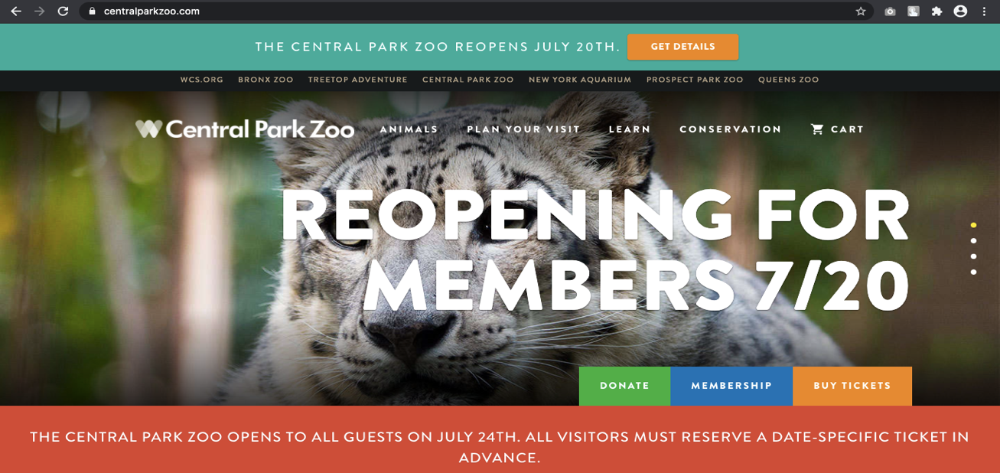

*Figure: Homepage (Landing Page)*

This is the homepage of the central park zoo. From this landing page, you can go to other pages such as ticket booking page, animal collection page, membership page, donation page and other pages. The website is very well managed. The website is user friendly. The design of the website is very attractive. The color in the website is used properly.



*Figure: Footer of the website*

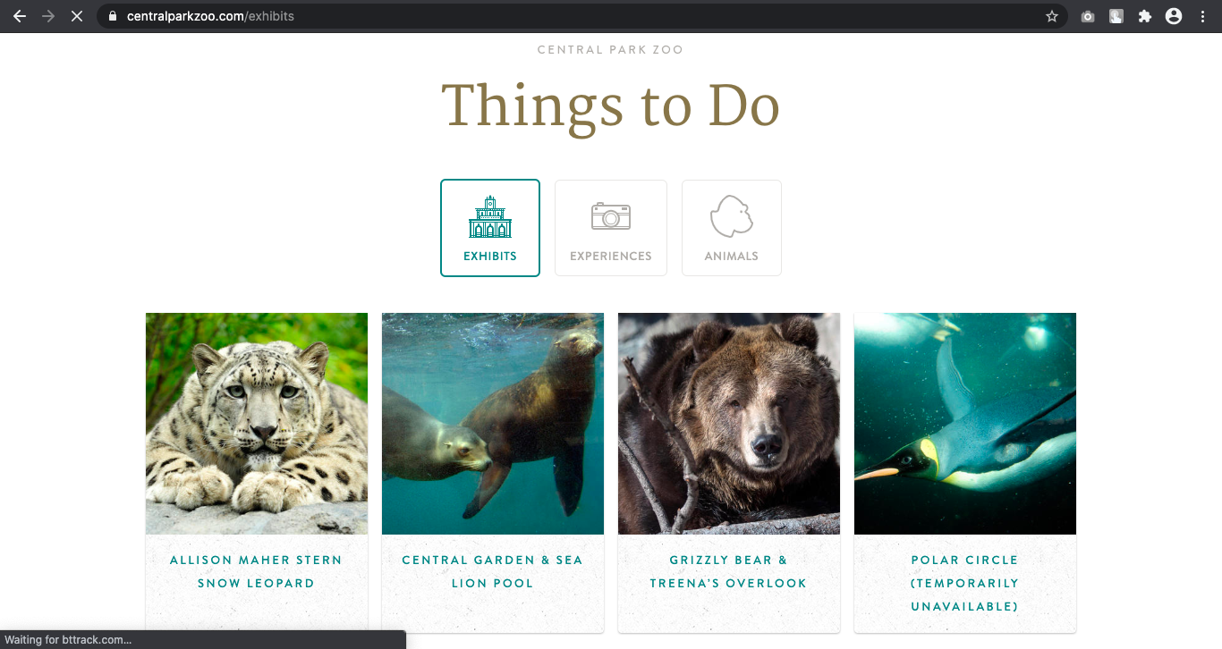

*Figure: Animal Information Page*

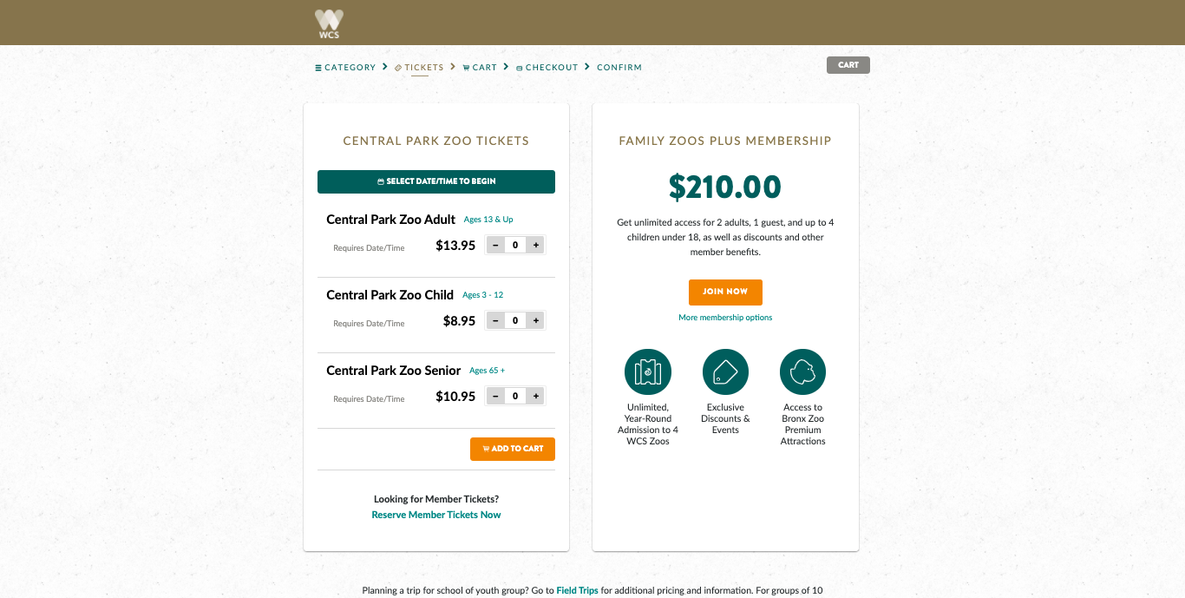

*Figure: Ticket Booking Page*

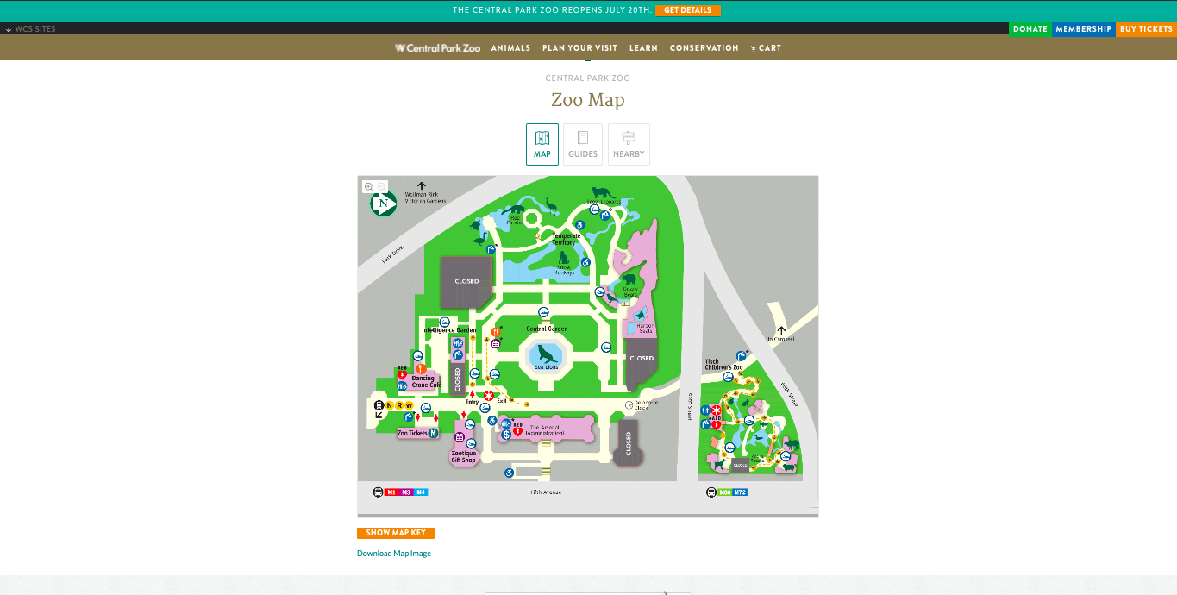

*Figure: Zoo Map Page*

**Features of Central Park Zoo**

* Login Portal for administration and visitor – There is separate login portal for administration and visitors. The admin can login from one portal to perform administrative work whereas the visitor can buy tickets and become a member by registering into the system.
* Animal Collection Page – The animal collection page shows the details information of the animal that is kept in the zoo.
* Ticket Booking System- You can book tickets online from anywhere and can pay the amount of the ticket from various payment methods. You cannot buy tickets if you are not registered as a member of the zoo.
* Zoo Map- There is a map of the zoo which shows all the information of animals that are kept in the zoo.
* News and Events – You can post news and events in the website from the administration area.
* Donations- Visitors and user can donate to the zoo from the website

**Design of Central Park Zoo**

* The design of the website is very responsive and clean. Users have quality of experience while surfing the website.
* The website provides information about all the things and is very user friendly.
* The website uses transition and animations which make it more attractive.
* **Franklin Park Zoo** (<https://www.zoonewengland.org/franklin-park-zoo.aspx>)

The other comparable system is Franklin Park Zoo. The website figures of different pages are shown below;

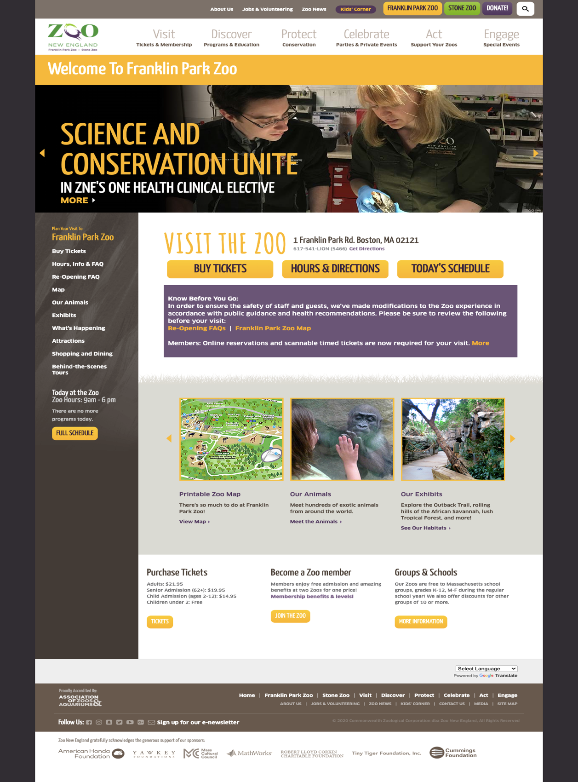

*Figure: Homepage (Landing Page)*

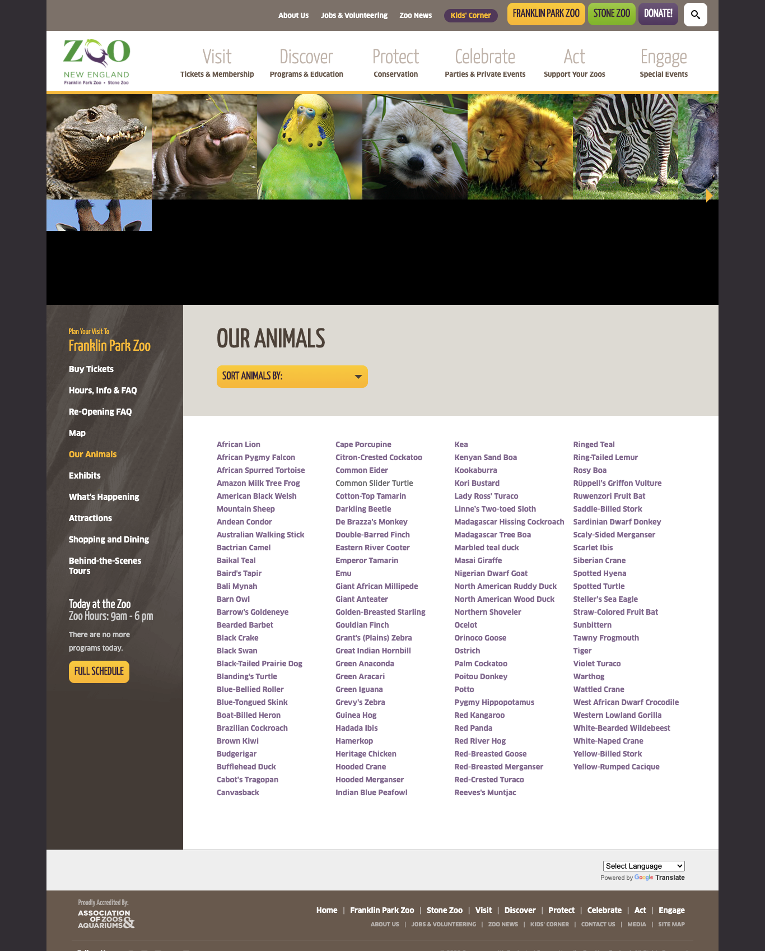

*Figure: Animal Information Page*

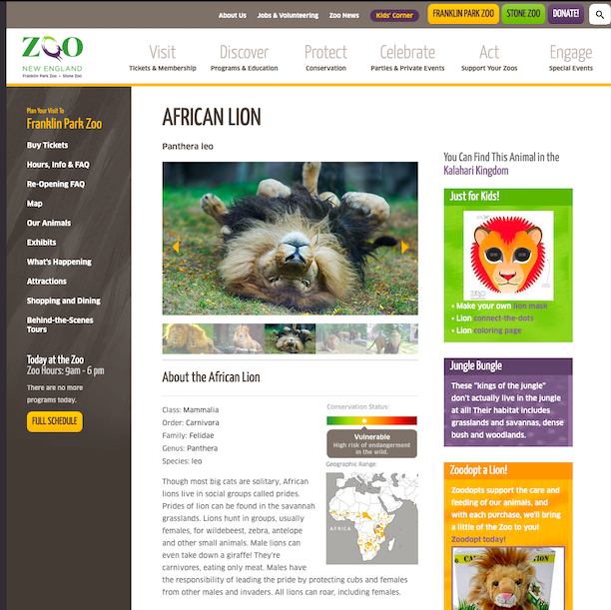

*Figure: Animal Information*

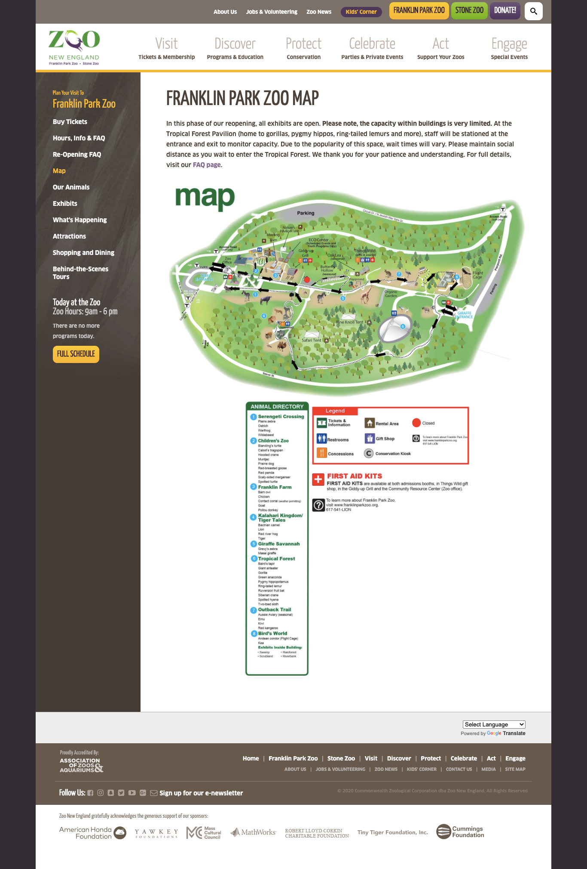

*Figure: Zoo Map Page*

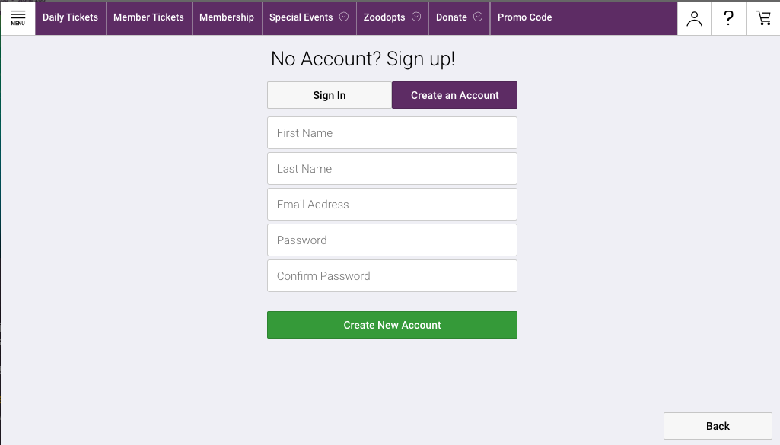

*Figure: User Sign Up Page*

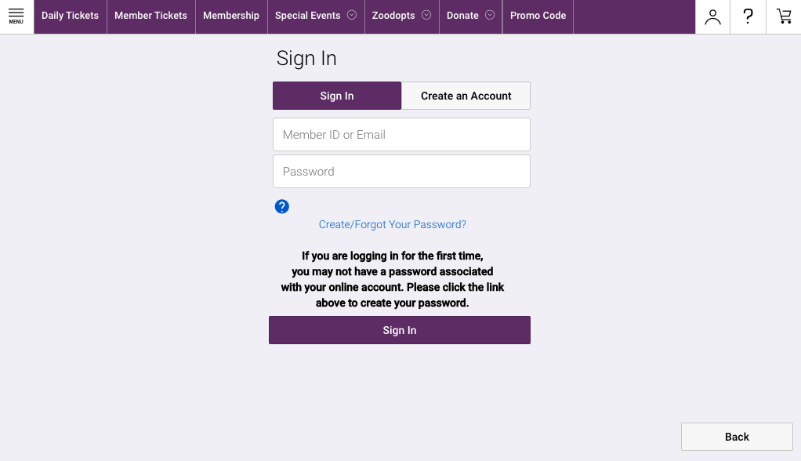

*Figure: User Sign In page*

**Features of Franklin Park Zoo**

* Login and Sign Up – Visitor can sign up as a member of the zoo. After signing up the user can perform activities such as buying tickets and so on.
* Advanced Search – In this website, the user can search the animal records on the basis of category and names.
* Animal Information- The animal information is managed properly and its rarity is also shown. Along with this, this website also shows the origin of the animals and where it is found in the world.
* Ticket Bookings – The visitors or user can buy ticket via online transaction in the website. They can buy tickets for group or for individuals.
* Special Events and News – Special events and news can also be shown in the website allowing visitors to visit the zoo in special events.
* Language Selection – This website provides language selection feature which allows user to read information on different languages.
* Membership – You can become member of the zoo by signing up as the member of zoo.
* Donation – You can donate amount in the zoo via online transactions.
* Kids Zone – This website provides different section for kids where they can play quiz and know information about the animals.

**Design of Franklin Park Zoo**

* The website is responsive and informative which allows user for smooth operation on the website.
* The graphics and animation used in the website is of very high quality and user can enjoy while visiting the website.
* The headers and footer information in the website is managed properly.

#### Development Relevant Legislation

The legislation is important part of the software development life cycle. We should consider certain laws and rule while developing the software system. The act and laws that we should follows are shown below;

1. The Data Protection Act (Data Protection Act 1998, 2020),

2. The Equality Act (Equality Act 2010, 2020), and

3. Computer Misuse Act (Computer Misuse Act 1990, 2020)

The Data Protection Act states that:

“Personal data shall be processed fairly and lawfully and, in particular, shall not be processed unless one of the conditions for ‘relevant for purposes of the data protection principles: processing of any person or processing of sensitive personal data’ is met.” (Data Protection Act 1998, 2020)

“Personal data processed for any purpose or purposes shall not be kept for longer than is necessary for that purpose or those purposes.” (Data Protection Act 1998, 2020)

Following steps have been made to abide the Data Protection act:

* The user privacy and policy would be highly confidential in the prototype system.
* The user would have high security while using the system. The data of the users would be protected.
* The user data would not be sold or used for other purposes.
* Only required information would be collected form the users. Unnecessary information would not be collected.
* The system would take user permission to use their data while processing.

The Equality Act states that:

“The Equality Act allows an employer or service provider or other organization to take positive action so as to enable existing or potential employees or customers to overcome or minimize a disadvantage arising from a protected characteristic.” (Equality Act 2010, 2020)

There would not be any discrimination the basis of skin color, age, race and so on. Everyone in the zoo would be treated equally. All the users would have the same features and functionality.

Computer Misuse Act states that:

“A person is guilty of an offence if he causes a computer to perform any function with intent to secure access to any program or data held in any computer or to enable any such access to be secured.” (Computer Misuse Act 1990, 2020)

## Requirements Specification

The requirements of the prototype software solutions should be met in this section. All the limitations should be solved by the prototype system. All the information that was collected in the elicitation activities is useful in this section. This section consists of design and commercial constraints, problem domain description, existing business operation, limitations and functional requirements.

### Problem Domain Description

The problem domain meaning the area of expertise that needs to be examined to solve a problem. In the problem domain, we only look at topics of individual interest and everything else is excluded. In here, the problem domain description entities include the limitation of current business method, operation of current business model, comparable system, stakeholders, and development relevant legislation.

For the development of the software solution system, it is necessary to extract key information using elicitation strategy. The below table represents the problem domain description:

|  |  |
| --- | --- |
| **Problem Domain Entities** | **Elicitation Strategies** |
| **Key Stakeholders - Mark Jones, John Smith, Georgia Rodgers, Laura Brown** | * Conducting workshop 1 for understanding of problem domain, limitations, functionalities, features, design and so on. * Conducting workshop 2 for solving the problems and starting the specification formulation that includes the functionality/ features, design, feature development priority and so on. |
| **Existing Business Operation and Limitations** | * All the client supplied documents and resources should be reviewed. * Conduction workshop to find out the current business model and operations along with the limitation of the existing model. |
| **Comparable Systems** | * Background research on comparable system that focuses on the design, features, functionality and so on. |
| **Development Relevant Legislation** | * Research on legal issues before developing the prototype software system. |

*Table 4: Problem Domain Description*

#### Existing Business Operation

The existing business method is clerical based system. All the work is done in papers. The Existing business Operation of the Claybrook Zoo is given below;

* Animal Records

The animal records are stored in a paper. They store the necessary information such as name, date of birth, species, and so on. All the information is collected and stored in clerical database.

* Sponsors
* Company or person approaches the Claybrook Zoo for sponsoring the animals.
* Claybrook Zoo takes the information of the client
* Sponsoring price is set by the zoo and the money is collected from the clients.
* Contract between the zoo and client is signed for a certain period of time.
* The sponsors name is then displayed below the animal’s information in the zoo.
* Ticket
* Ticket is purchased in the zoo premises and the bill is presented to the visitors.

#### Summary of Existing Business Limitations

The present system of Claybrook Zoo is a clerical based system. All the records are managed clerically. All the animals, sponsors, tickets are managed in papers. Due to the clerical based system, the process is very slow and time consuming. All the other organizations and business converted their operations from paper based to software system so, the zoo also wanted to convert their clerical based system to a software system.

There were many limitations in the clerical based system. The main areas of the limitation of the zoo were security, reliability, efficiency and so on. The creating, updating, search process is very time consuming. The staff have to manage all the records manually. Since, all the records were kept in papers, there were high chances of losing the data. It would require a lot of space to collect the data file. If an employee wants to search some data file, it would take a very long time to process those files and find the respective file. Due to these limitations, the zoo wants to convert their system from clerical based to computerized software system.

### Functional Requirements

In this section of the report, we present the functional requirements for the development of the software system. These functional requirements would solve all the previous limitations of the organization and also add new features and functionalities.

All the necessary information required to develop the software system is collected from the elicitation activities. All the features and operation access level are given in this section of the report. The following tables would show the access level of administrator and other users and the attributes of the respective table.

|  |  |  |
| --- | --- | --- |
| **Operations** | **Staff/Administrator** | **Visitor/Customers** |
| Create Animal Records | Full access | No access |
| Update Animal Records | Full access | No access |
| Delete Animal Records | Full access | No access |
| Archive Animal Records | Full access | No access |
| Assign Sponsor to Animal | Full access | No access |
| Search Animal Records | Full access | Full access |
| Read Animal Information | Full access | Full access |

*Table 5: Animal Records Operations and Access Levels*

|  |
| --- |
| Animals |
| Entity Name | **Type** | **Notes** |
| Animal Id | Integer (20) | Assigned identification number to animal |
| Species Name | Varchar (255) | Name of the species |
| Animal Name | Varchar (255) | Name of the animal |
| Habitat | Varchar (255) | Habitat of the animal |
| Diet | Text | Dietary supplements required for the animal |
| Date of birth | Date (DD-MM-YY) | The date the animal was born |
| Date of join | Date (DD-MM-YY) | The date the animal was joined in the zoo |
| Average life span | Integer (20) | Average life span of the animal |
| Gender | Enum () | Gender of the animal |
| Height | Integer (20) | Height of the animal |
| Weight | Decimal () | Weight of the animal |
| Image | Varchar (255) | Image of the animal |
| Archived | Enum () | To archive the animal |
| Category Id | Varchar (255) | Category identification number of the animal i.e. mammals, reptiles, etc. |
| Sponsor Id | Varchar (255) | Sponsor identification number |
| Band | Enum () | Band of the animal |
| Price | Decimal () | Price for sponsoring the animal |
| Agreement Form | Date (DD-MM-YY) | Sponsorship agreement form date |
| Agreement To | Date (DD-MM-YY) | Sponsorship ending date |
| Signage | Varchar (255) | Signature name of the member of zoo for agreement form. |

*Table 6: Animal Records*

|  |
| --- |
| Categories |
| Entity Name | **Type** | **Notes** |
| Category Id | Integer (20) | Unique Identification number of the animal category |
| Category Name | Varchar (255) | Category Name of the animal i.e. either the animal is mammal, reptile bird or fish. |

*Table 9: Category Records*

|  |
| --- |
| Birds |
| Entity Name | **Type** | **Notes** |
| Bird Id | Integer (20) | Unique Identification number of the bird |
| Nest | Varchar (255) | Nest type of the bird |
| Clutch Size | Integer (20) | Clutch size of the bird |
| Wingspan | Integer (20) | Wingspan of the bird |
| Ability to Fly | Enum () | The ability of a bird to fly |
| Plumage Color Variants | Varchar (255) | Plumage color of the bird |
| Animal Id | Integer (20) | Unique Identification number of the animal |

*Table 10: Bird Records*

|  |
| --- |
| Fishes |
| Entity Name | **Type** | **Notes** |
| Fish Id | Integer (20) | Unique Identification number of the bird |
| Body Temperature | Decimal () | Body temperature of the fish |
| Water Type | Varchar (255) | Type of water |
| Fish Color | Varchar (255) | Color of the fish |
| Animal Id | Integer (20) | Unique Identification number of the animal |

*Table 11: Fish Records*

|  |
| --- |
| Mammals |
| Entity Name | **Type** | **Notes** |
| Mammal Id | Integer (20) | Unique Identification number of the bird |
| Gestation Time | Integer (20) | Gestation time of the mammal |
| Category | Varchar (255) | Mammal category |
| Body Temperature | Decimal () | Body temperature of the mammal |
| Animal Id | Integer (20) | Unique Identification number of the animal |

*Table 11: Mammal Records*

|  |
| --- |
| Reptile/ Amphibian |
| Entity Name | **Type** | **Notes** |
| Reptile Amphibian Id | Integer (20) | Unique Identification number of the bird |
| Reproduction | Enum () | Either by giving birth or egg reproduction |
| Clutch Size | Integer (20) | Clutch size of the animal |
| Offspring | Integer (20) | Offspring of the animal |
| Animal Id | Integer (20) | Unique Identification number of the animal |

*Table 12: Reptile/Amphibian Records*

|  |
| --- |
| Admin |
| Entity Name | **Type** | **Notes** |
| Admin Id | Integer (20) | Unique Identification number of the administrator |
| Username | Varchar (255) | Username of the admin |
| Password | Varchar (255) | Password of the admin |

*Table 7: Admin Records*

|  |  |  |
| --- | --- | --- |
| **Operations** | **Staff/Administrator** | **Visitor/Customers** |
| Create Sponsor Records | Full access | No access |
| Update Sponsor Records | Full access | No access |
| Delete Sponsor Records | Full access | No access |
| Archive Sponsor Records | Full access | No access |
| Search Sponsor | Full access | No access |
| Read Sponsor Information | Full access | Limited Access |

*Table 8: Sponsor Records Operation and Access Levels*

|  |
| --- |
| Sponsors |
| Entity Name | **Type** | **Notes** |
| Sponsor Id | Integer (20) | Unique Identification number of the sponsor |
| Name | Varchar (255) | Name of the sponsor |
| Existing customer | Enum () | Is the sponsor existing sponsor or not |
| Company Id | Integer (20) | Name of the company |
| Primary number | Varchar (255) | Primary contact number |
| Secondary number | Varchar (255) | Secondary contact number |
| Country | Varchar (255) | Name of the country |
| City | Varchar (255) | City name |
| Street | Varchar (255) | Street |
| Note | Text | Special note |
| Agreement | Text | Agreement |
| Payment | Text | Payment for sponsoring an animal |
| Signage image | Varchar (255) | Image of the sponsors |
| Payment Received | Enum () | Payment received or not |
| Reviewed Date | Date (DD-MM-YY) | Reviewed date |
| Signed Date | Varchar (255) | Signed Date |

*Table 9: Sponsors Records*

All these records are managed by either the administrator or the staff of the Claybrook zoo. The records can be created, updated, archived, deleted, searched and so on. The information of the animals, sponsors, maps can be read by the visitors.

### Proposed Prototype Development Blocks/Priority of Development

The prototype software system will be developed into blocks on the basis of important features and functionality. Since we are using the RAD method for the development of the software system, the development of the software is divided into blocks. There are many advantages of using this development method. We can divide the development process into blocks which makes the development process easier and convenient. If the client wants to make changes in the software, in this method the changes can be made without hampering the time and cost to complete the project.

Information collected from the workshop finding suggest that the basic requirements should be prioritized at first during the development process. The development process can be divided into required number of blocks on the basis of features and functionalities.

* Software Development Phase 1
* Creating Claybrook Zoo Database
* MVC Framework for the development of the software
* Secure Login Portal for administrator or staff
* Graphic User Interface Designing
* Animal records create, update, delete, archive, read operations
* Animal Category create, update, delete, read operation
* Software Development Phase 2
* Complex search criteria operations
* Sponsors create, update, delete, archive, read operations
* Animal and sponsors advance search operation
* Assigning sponsor to animal operation
* Advance security access feature development
* Software Development Phase 3
* Producing example internet-ready pages that allows visitors to look at the catalogue of animals held within the zoo
* Responsive design in various devices
* Automated ad-hoc reports generation for key business events

The basic features are developed in the software development phase 1 and 2 whereas the advanced features will be developed in the software development phase 3.

# System Analysis & Design (Software Development Block 1)

In the system analysis and design part, the information gathered during the different phases of the elicitation activities and requirement engineering are examined. The analysis and design consist of different phases which are:

## Preliminary Design Stages

The information gathered in the requirement engineering section are examined with the help of textual analysis. In the software solution system, the different classes to be used are identified with the help of the textual analysis. In the textual analysis part there is candidate and the candidate authority.

### Textual Analysis

|  |  |
| --- | --- |
| **Candidate** | **Candidate authority** |
| Admin/Staff | Login  Dashboard access  All Record access  Add animal/sponsor information  Update/Edit animal/sponsor information  Archive records of animals or sponsors  Search records of animals or sponsors  Assign Sponsors to animals  Manage users  Mange tickets  Logout |
| Visitor/Users | Login  Access animal information  Access Map of the zoo  Access sponsor information  Search animal  Buy tickets  Logout |

### Significant Event Analysis

|  |  |  |
| --- | --- | --- |
| **Event** | **Performers** | **Attributes** |
| Login | Admin/Staff  Visitors | Username  password |
| View animal information | Admin/Staff  Visitors | Animal Id (Admin only)  Species Name  Animal Name  Habitat  Diet  Date of birth  Date of join  Average Life span  Gender  Height  Weight  Image  Archive  Sponsors |
| View Sponsors Information | Admin/Staff  Visitors | Sponsor Id (Admin Only)  Name  Existing Customer (Admin Only)  Company Id  Primary Number  Secondary Number  Country  City  Street  Note  Agreement  Payment (Admin Only)  Signage Image  Payment Received (Admin Only)  Review Date (Admin Only)  Signed Date (Admin Only) |
| Search Animal Records | Admin/ Staff  Visitors | Animal Name  Category |

## Activity UML Diagram

The Activity UML Diagram is used to describe the dynamic aspect of the software system. In this UML diagram there is flow of activity. These activities are also known as an operation of the system.

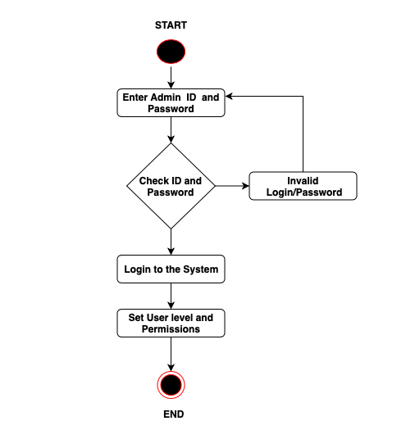

*Figure: Claybrook Login Activity Diagram*

The above figure represents the login activity diagram of the Claybrook Zoo system. As you can see in the figure there is a flow of activity from one to another. In this diagram the admin has to enter the correct username and password in order to get access to the administration are. If the user does not provide correct username and password then the cannot access the administration are.

## Use Case Diagram

Use Case Diagram is one of the important parts of the system design and analysis. The use case diagram is used for capturing the functional requirements of the system. Basically, it describes the external view of the system and the interaction of the external view with the outside world.

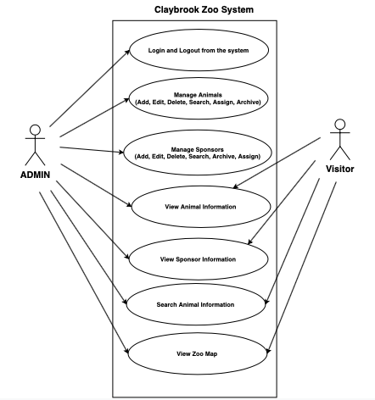

*Figure: Use Case Diagram of Claybrook Zoo*

The above figure shows the relation of actors i.e. admin and visitors with the use case of the system.

## Sequence Diagram

The interaction between objects in time sequence is known as sequence diagram. The admin login sequence diagram is shown below in the figure;

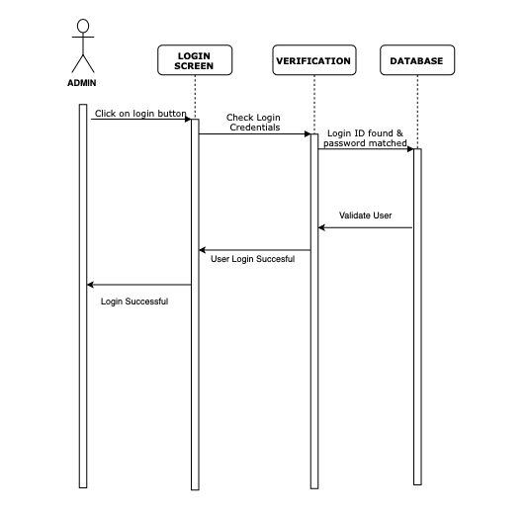

*Figure: Admin Login Sequence Diagram*

When the admin provides the login credentials in the system, the system checks whether the provided username or password is correct or not. If the password and username match the database credentials than the user would be able to login to the system. Otherwise, the system would reject the username or password and the user cannot login to the system.

## System Navigation Diagram

The system navigation diagram is used for showing the navigation of the system software. This navigation diagram helps user to understand the different pages used in the system. The navigation diagram of the admin website is shown below in the figure:

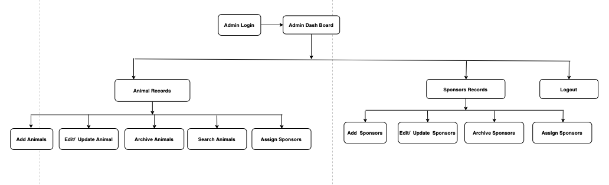

*Figure: Admin System Navigation Diagram*

The above figure shows the navigation diagram of the admin website. From the figure, we can see that when an admin login to the system, they are directed to the dashboard. From the dashboard they can manage animals and sponsors.

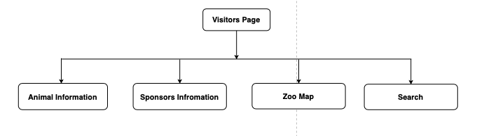

*Figure: Visitor System Navigation Diagram*

The above figure shows the navigation diagram of visitor website. You can see the animal information, sponsor information, zoo map and so on. The visitor can also search the animals on the basis of category also.

## Database Design

The entity relationship diagram of the Claybrook zoo is shown in the figure below. This database is used for the development of the software system.

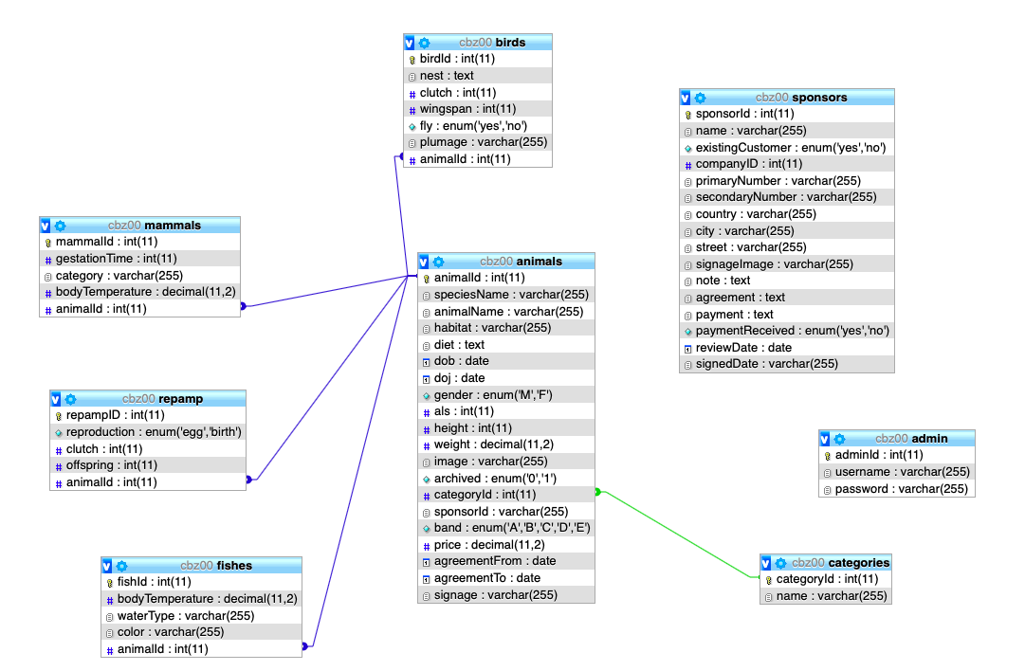

*Figure: EER Diagram of Claybrook System*

# System Build and Technical Notes (Software Development Block 1)

The system builds and technical notes is the coding part of the prototype software system. The MVC framework is used while developing the prototype software system. The MVC framework reduces the code redundancy and the code can be understandable by any other developers. This MVC framework is the latest way of developing a software system. The folder of the project is divided into MVC pattern i.e. it is divided into classes, functions, pages and templates. The administration part i.e. backend of the software system is built separately from the front-end part i.e. the visitor part. This pattern is mostly followed by all the developer’s team in the world. This makes the software more reliable.

The below figure shows the MVC folder pattern:

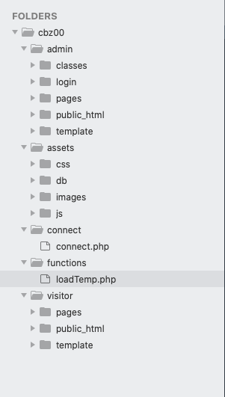

*Figure: MVC Framework Pattern of Claybrook Zoo*

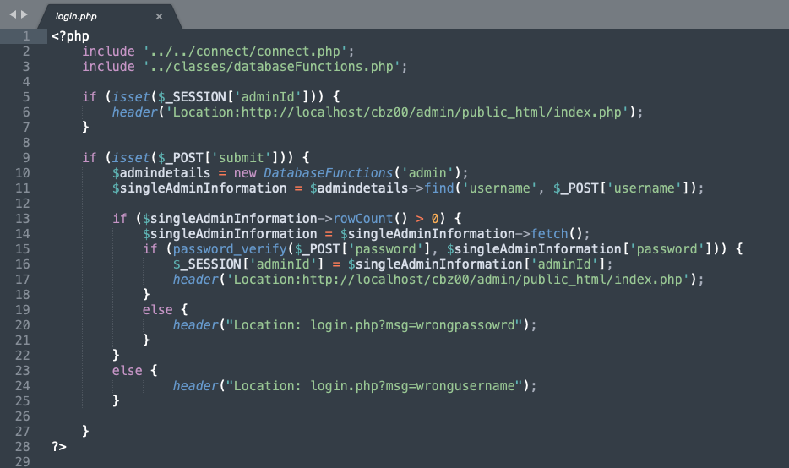

*Figure: Admin Login*

In the above code, the system connects to the database function. When the user inputs the username and password into the login page, the system checks whether the username or password is present in the database directory. If the username or password matches the database directory then the admin is login into the system. The login is a very secure process since the password is hashed and no one can crack the password easily.

If the password or username does not match in the database system, the user is again redirected to the login page.

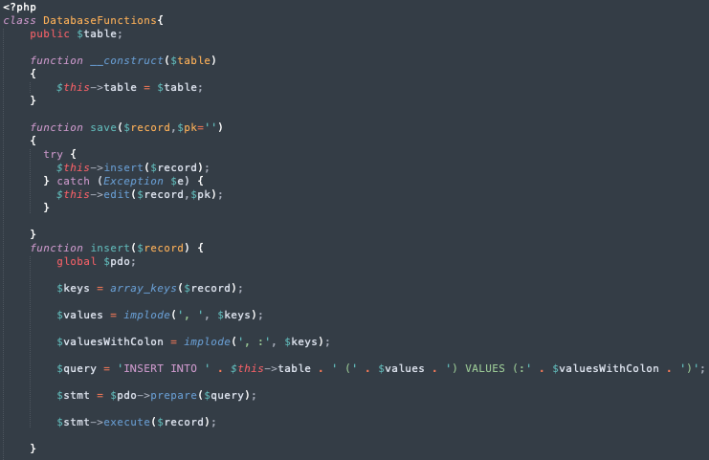

*Figure: Database functions*

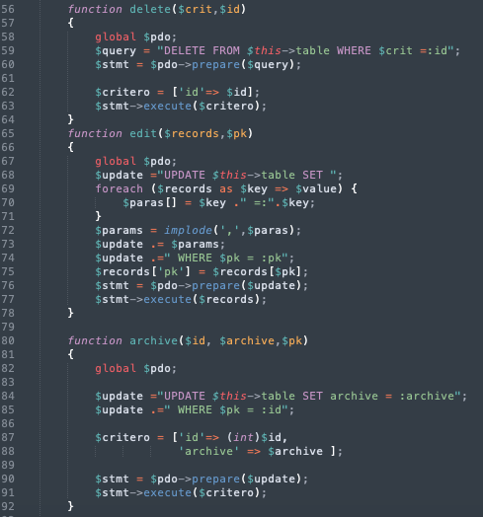

*Figure: Database Functions*

The above code shows the database functions that is used for inserting, updating, editing, deleting, archiving and saving information in the database table. The function is created so that we can use these functions in the places that we like. We don’t have to over write the code. We can just include the functions in the required page. This helps in reducing the redundancy of code in the software system.

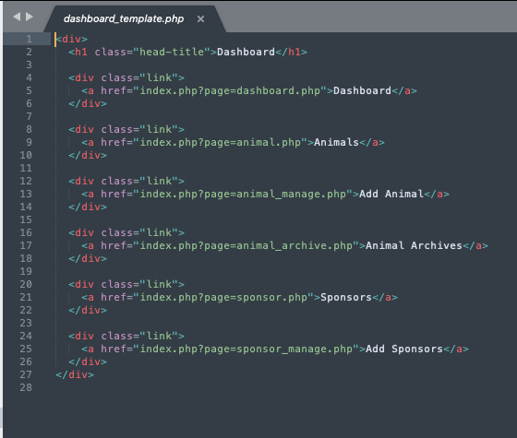

*Figure: Admin Dashboard*

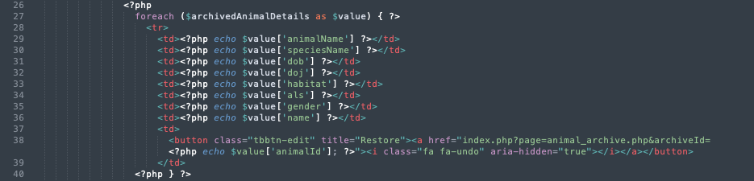

*Figure: Animal Archive*

The admin dashboard page is shown when a user is logged in to the system. There are links to various pages such as add animal, add sponsors and so on. When a user clicks the certain link, they would be directed to that page from the dashboard.

To archive an animal, when a user clicks the archive button all the information regarding the animal is hidden and stored in another database. The information can also be un archived from the animals unarchived table. When a user clicks the archive button, all the information is collected from the animals record and the information is withdrawn from that table to another table.

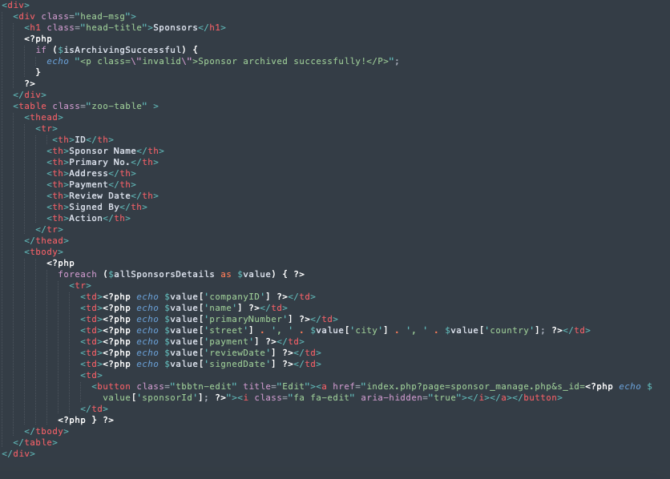

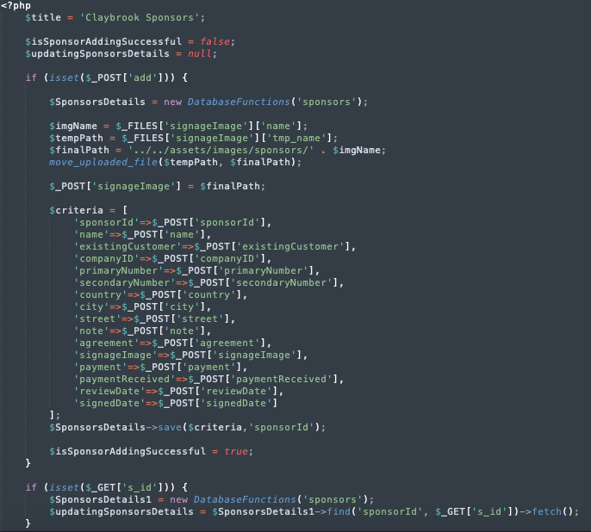

*Figure: Add Sponsor*

When all the required information is filled in the form the information is saved into the database with the help of the database function. The sponsor table is already made into the database. When the user clicks the add button the sponsors information is saved into the database.

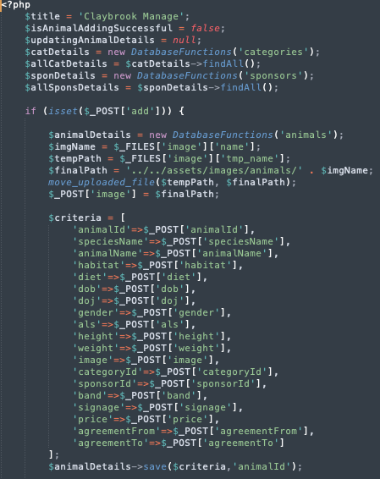

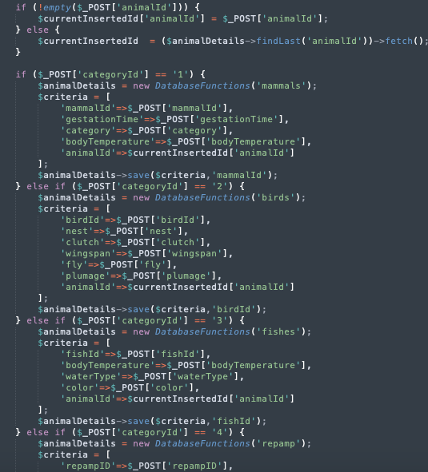

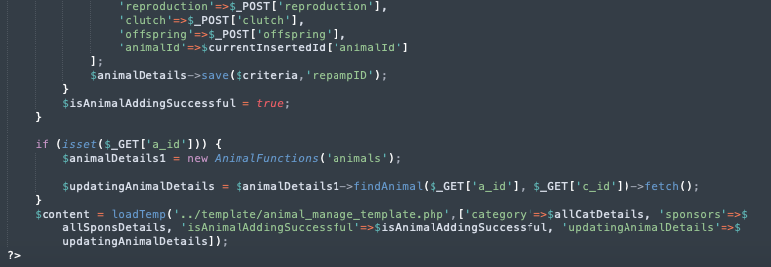

*Figure: Manage Animal*

The database table categories, animals and sponsors are required to fulfill the information of the animal into the animal table. Required database table is included into the path as you can see in the above figure. When the user clicks the add button the animal’s records are added into the animals table and is shown in the system. There are currently four type of animals i.e. mammals, reptiles, fishes and birds. The user has to select any one of the categories to add the animal into the records. When a user selects a certain category, the category attributes are automatically added into the database table.

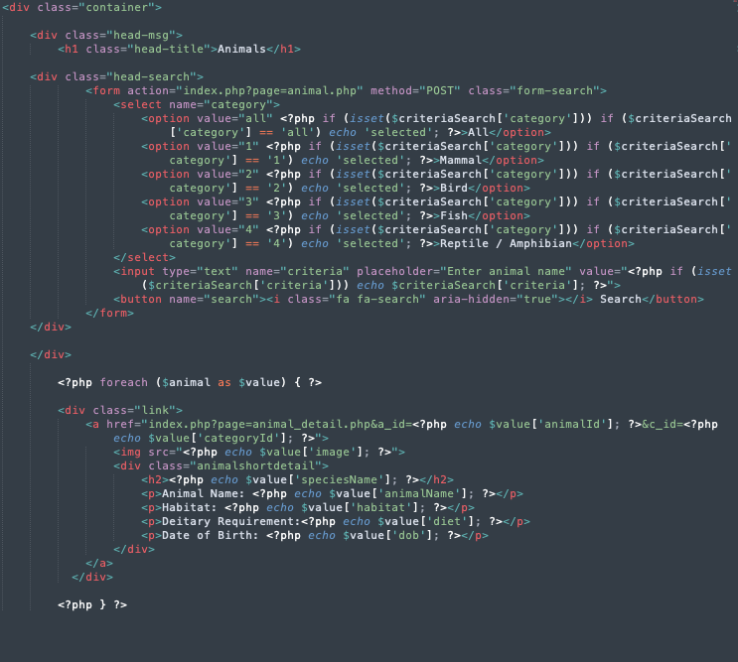

*Figure: Advance Search*

The advanced search method is used for searching animal records. When a user selects the category of animal for search, the system finds the selected category and then displays into the system. Similarly, the user can also search with animal’s name and so on. The search method also uses like operators to find out the results. When a user does not know a specific name, then he/ she can search with minimum letters and the system display the results.

# System Testing & Evaluation Strategy (Software Development Block 1)

Testing is one of the important parts of the software development life cycle. After developing the software testing is necessary to find out the performance and limitations of the software. All the problems that were in the previous system should be solved by the software system. Black Box testing method is used in this software development method. The following table shows all the testing carried out:

|  |  |  |  |
| --- | --- | --- | --- |
| **Test** | **Expected Outcome** | **Actual Outcome** | **Error/ Fix** |
| **Login test with both valid and invalid username and password** | | | |
| (Admin) Valid Login  Username-roshan  Password- roshan123 | * Successful login to the system * Shows the admin dashboard | ✓ | - |
| Invalid Login (Admin)  Username- roshan  Password-  123 | * Unsuccessful login to the system * Redirect to the login page and shows password error | ✓ | - |
| **Add animal details in the database table** | | | |
| Add Animal  Details | * Add animal successfully * Show Animal information in the animal record table. | ✓ | - |
| **Add Sponsor Information in the system** | | | |
| Add Sponsors Details | * Add sponsor successfully * Show Sponsor information in the Sponsor record table. | ✓ | - |
| **Assign Sponsors to animals** | | | |
| Assign sponsor to animal | * Sponsor should be successfully assigned * Sponsors information should be shown below animal information | ✓ | - |
| **Archive animal record** | | | |
| Archiving animal record | * The animal record should be archived * The animal record should be displayed in the archives table | ✓ | - |
| **Search Animals on the basis of category** | | | |
| Searching Animal records  Category- ‘Bird’ | * The animal record should be displayed | ✓ | - |
| **Logout from the System** | | | |
| Logging out from the system | * The admin should be log out from the system * It should display the login panel when logout from the system. | ✓ | - |

*Table: Black Box Testing*

# Conclusion

The prototype system is developed by Rapid Development Method (RAD) along with the JAD session with stakeholders of the organization. All the necessary requirements are fulfilled by this prototype software system along with some additional new features and functionalities. It solves all the limitation of the existing business model. The process is no longer time consuming and is very efficient and reliable. The software development phase 1 and 2 have been covered but the remaining additional features have not been implemented in the prototype system.

All the necessary information was collected from the provided documents and other information was collected with key stakeholders of the organization which makes the elicitation process easy. The JAD workshop helped in understanding the problem domain of the current business model. The software developer team work alongside with the stakeholder on the design part of the prototype software system. The member of the organization was very co-operative and all the necessary information required to developed the prototype software system was collected.

After the necessary information was collected, the developer team can move with the development of the prototype software system. The development of the software was divided into different phases. Basic features and functionality were prioritized at the first and second phase of the development and advanced features and functionality were prioritized at last phase. At the beginning, the database model for the designed. After designing the database model, the MVC framework pattern was chosen for the development process.

When the development process was completed, black box testing of the prototype software system was done which proves that the system is robust, flexible, efficient and reliable. Further additional functionalities can be added in future to make the system perfect.

# References

Legislation.gov.uk. 2020. *Data Protection Act 1998*. [online] Available at: <https://www.legislation.gov.uk/ukpga/1998/29> [Accessed 18 May 2020].

Legislation.gov.uk. 2020. *Equality Act 2010*. [online] Available at: <https://www.legislation.gov.uk/ukpga/2010/15> [Accessed 18 May 2020].

Legislation.gov.uk. 2020. Computer Misuse Act 1990. [online] Available at: <https://www.legislation.gov.uk/ukpga/1990/18> [Accessed 18 May 2020].

# Appendix

## Wireframes

**Admin Wireframe**

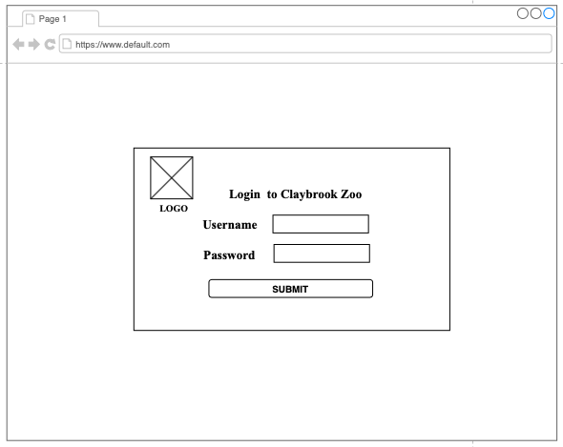

*Figure: Login Page*

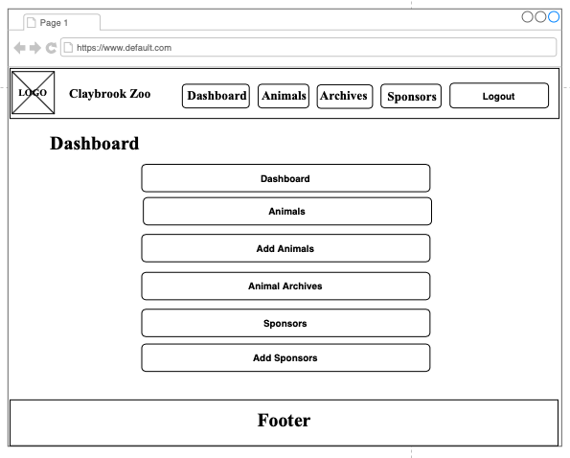

*Figure: Dashboard page*

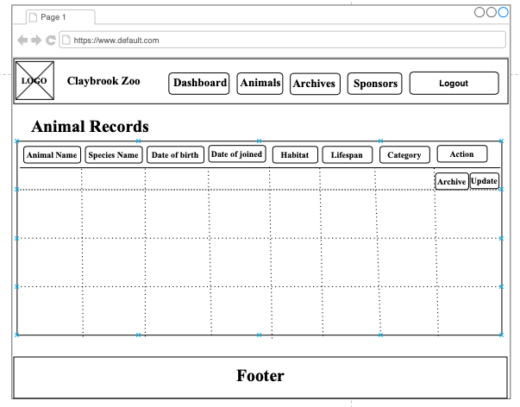

*Figure: Animal Records page*

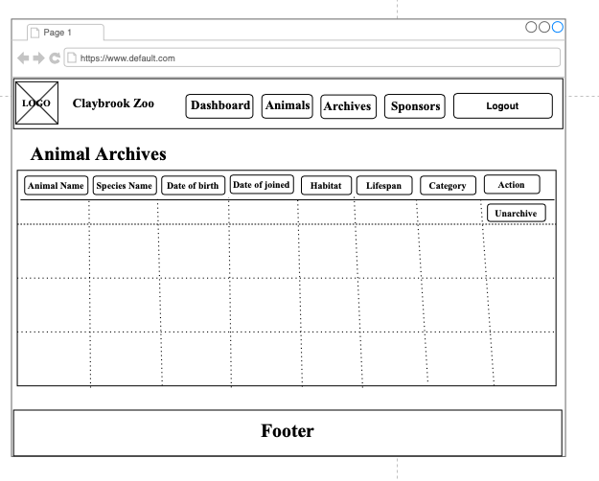

*Figure: Archives Record Page*

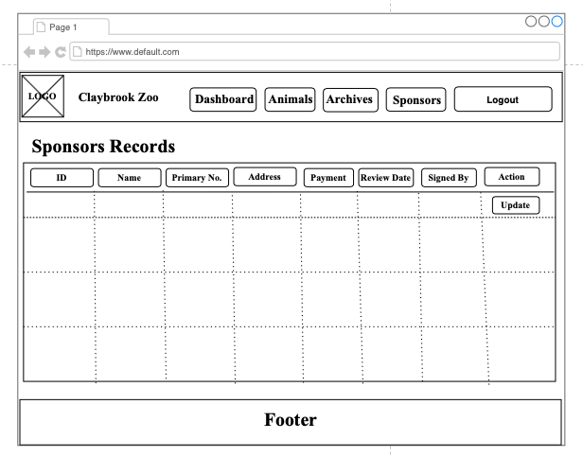

*Figure: Sponsor Record Page*

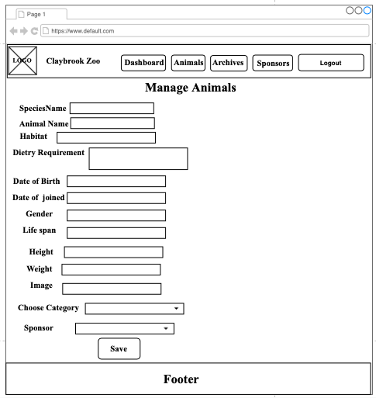

*Figure: Add Animals Page*

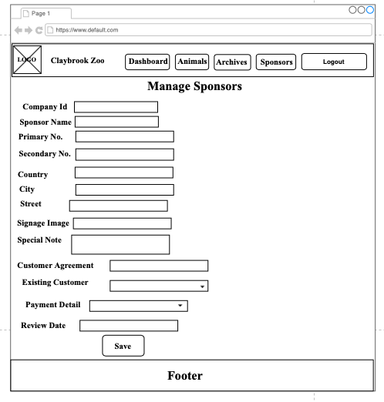

*Figure: Add Sponsors Page*

**Visitor Wireframe**

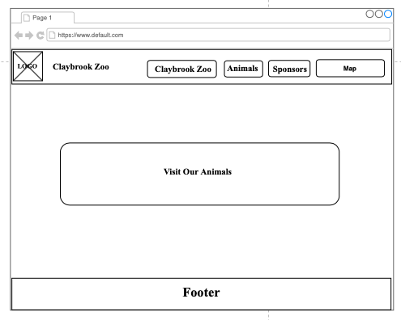

*Figure: Index Page*

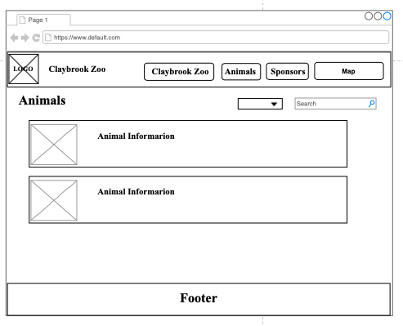

*Figure: Animal Information Page*

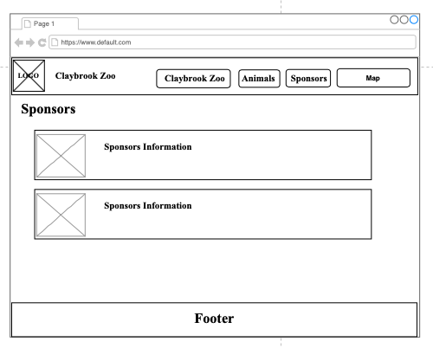

*Figure: Sponsor Information Page*

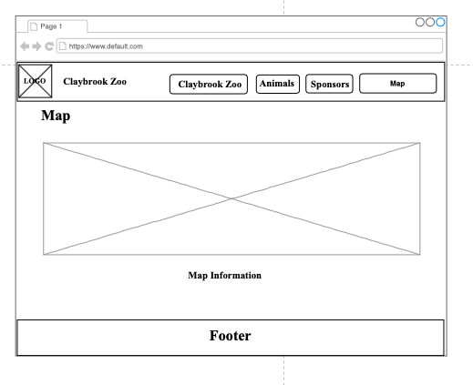

*Figure: Zoo Map Page*

## Mockups

**Admin Mockups**

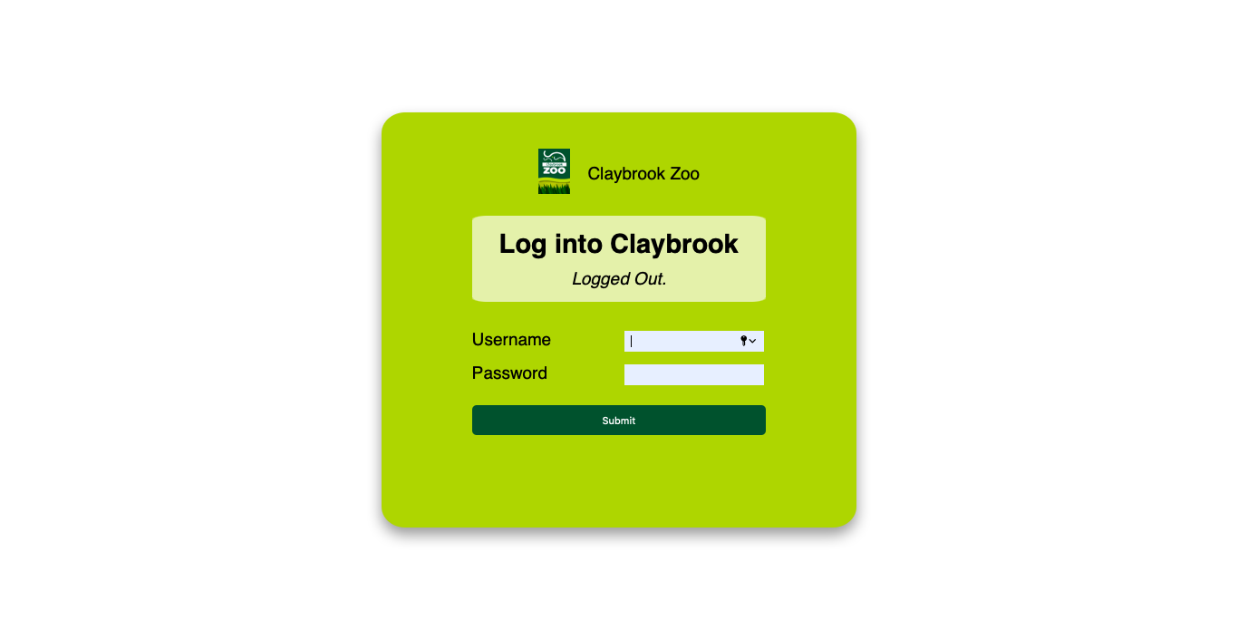

*Figure: Login Page*

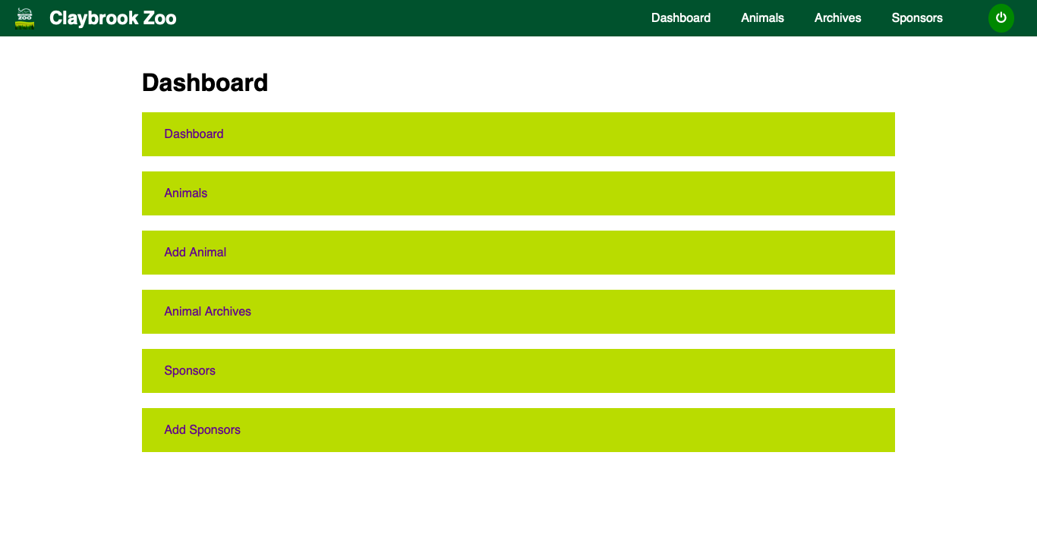

*Figure: Dashboard Page*

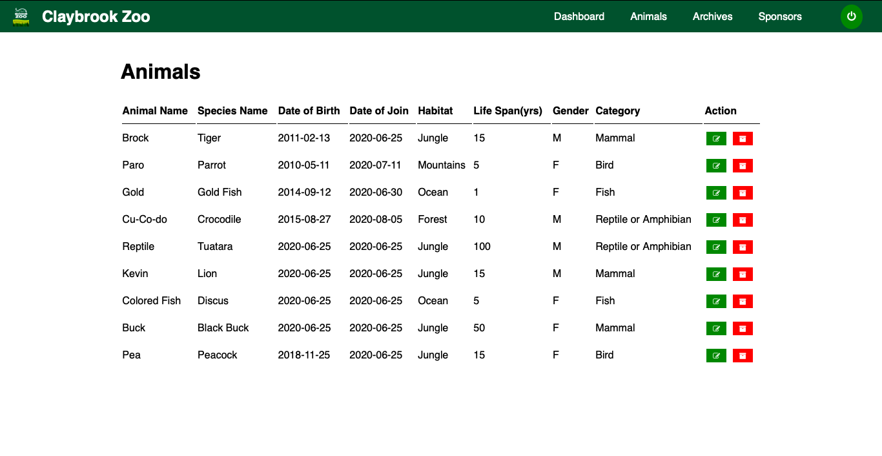

*Figure: Animal Record Page*

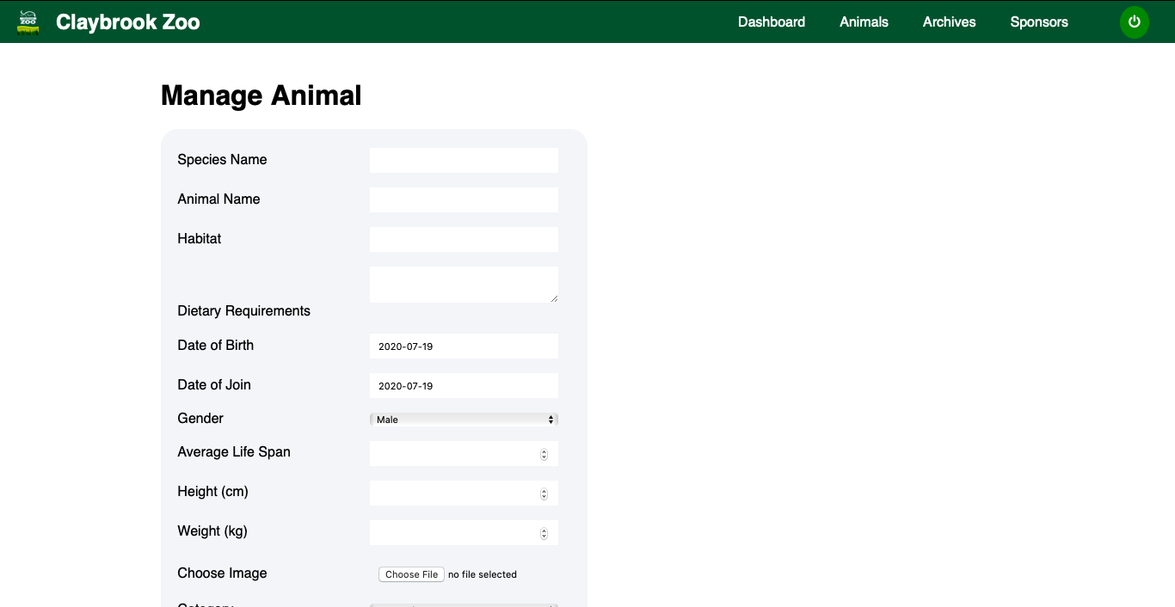

*Figure: Add Animal Page*

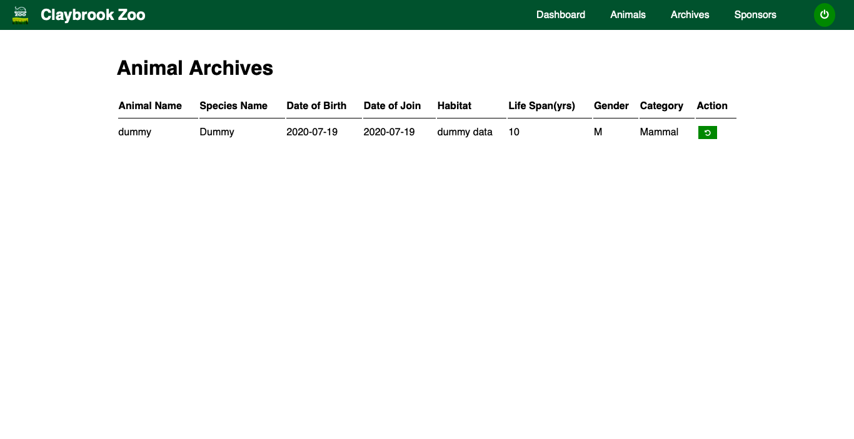

*Figure: Animal Archive Page*

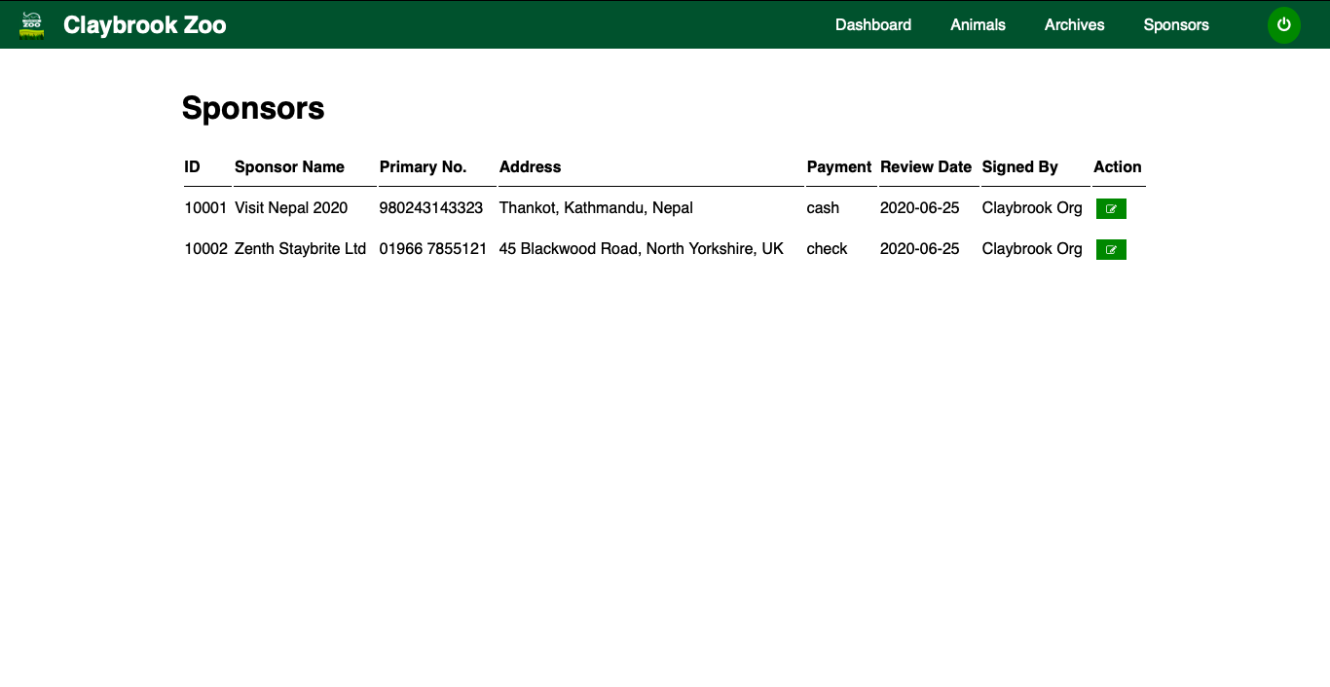

*Figure: Sponsors Record Page*

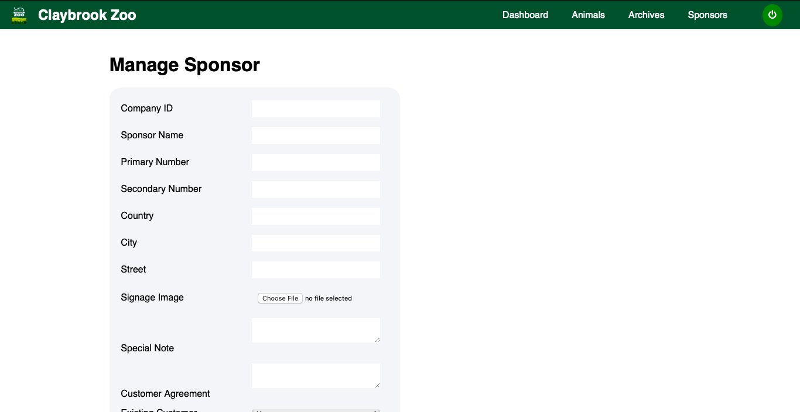

*Figure: Add Sponsors Page*

**Visitors Mockups**

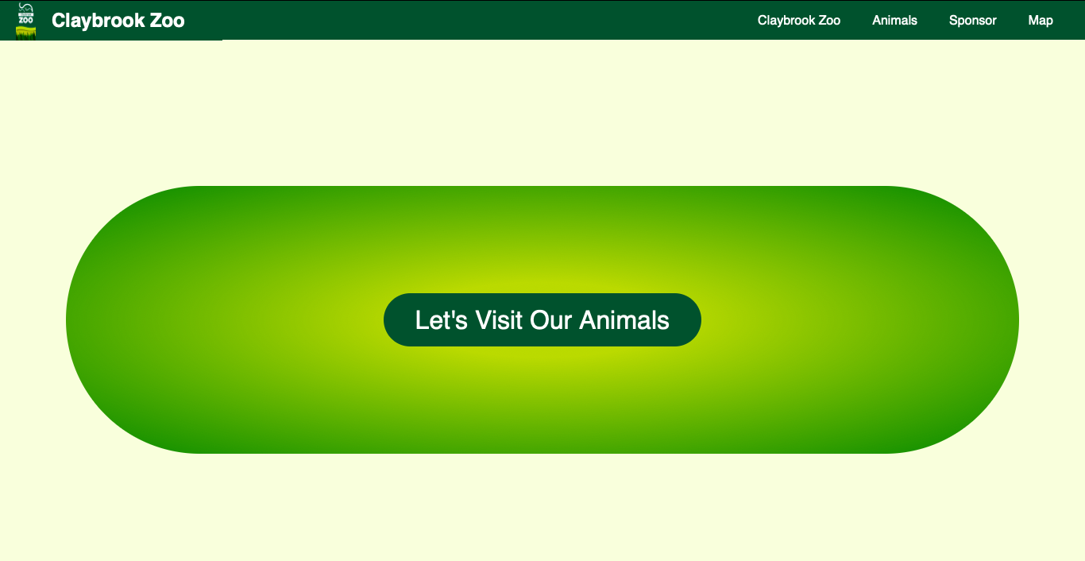

*Figure: Index Page*

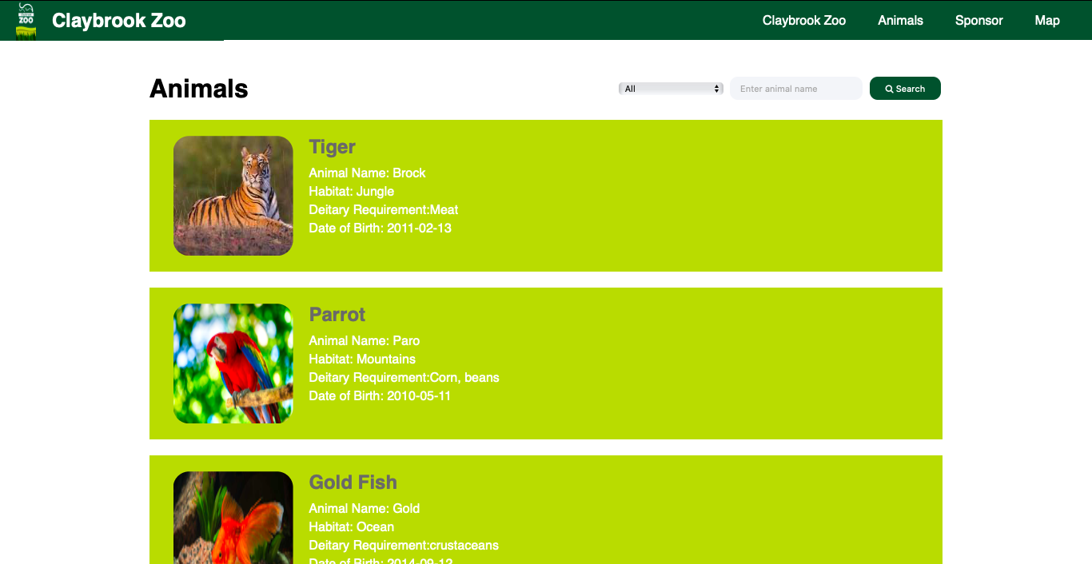

*Figure: Animal Information Page*

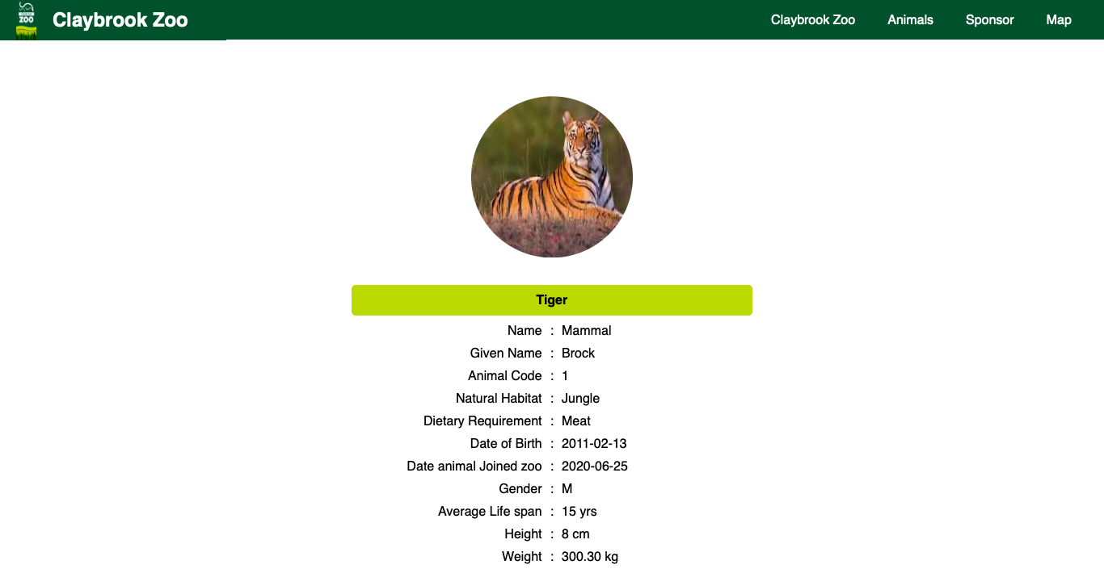

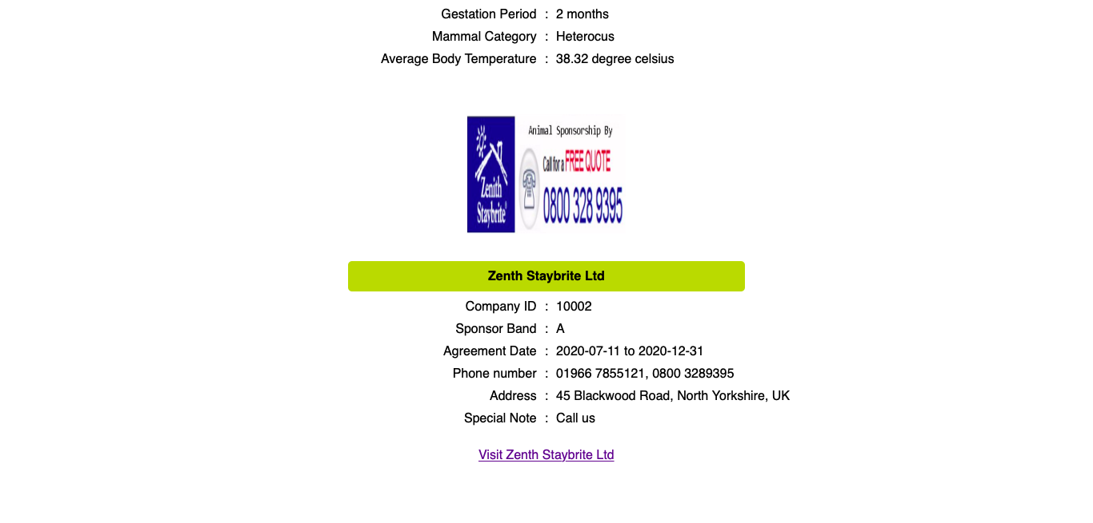

*Figure: Animal Detail Information Page*

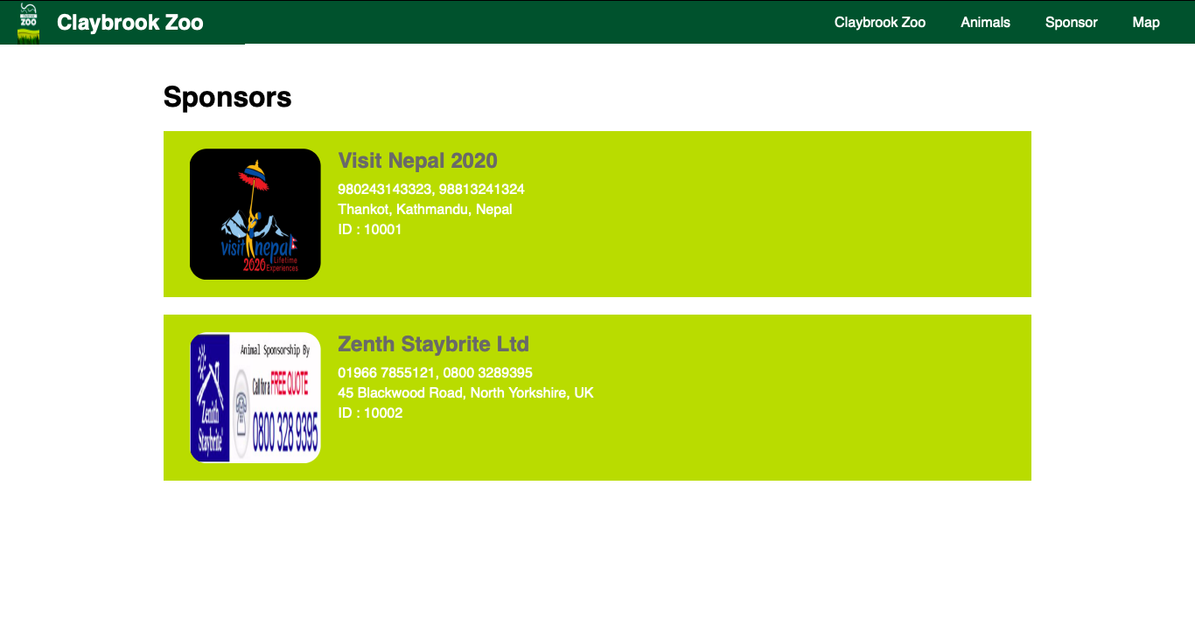

*Figure: Sponsors Information Page*

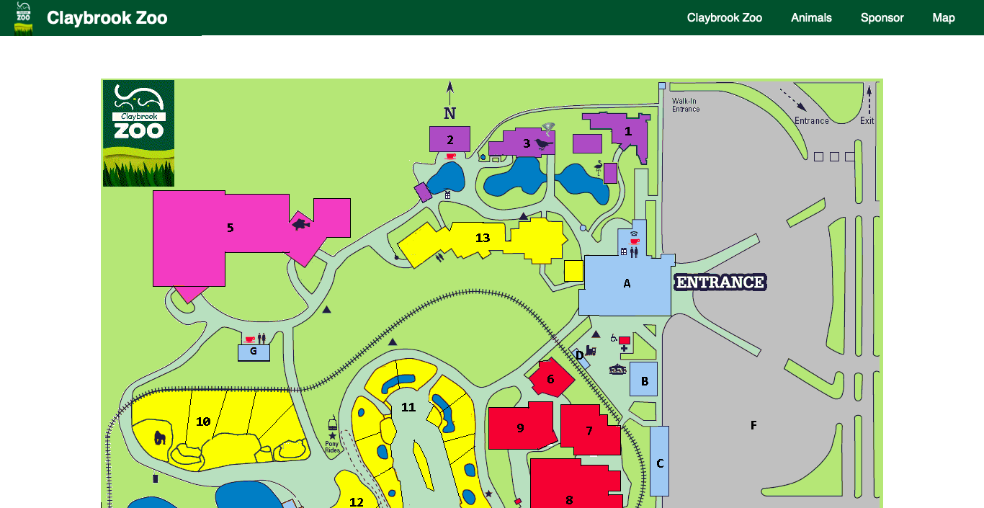

*Figure: Zoo Map Page*